Criteria:
Alternatives: Voices for Justice
Judy Bonds
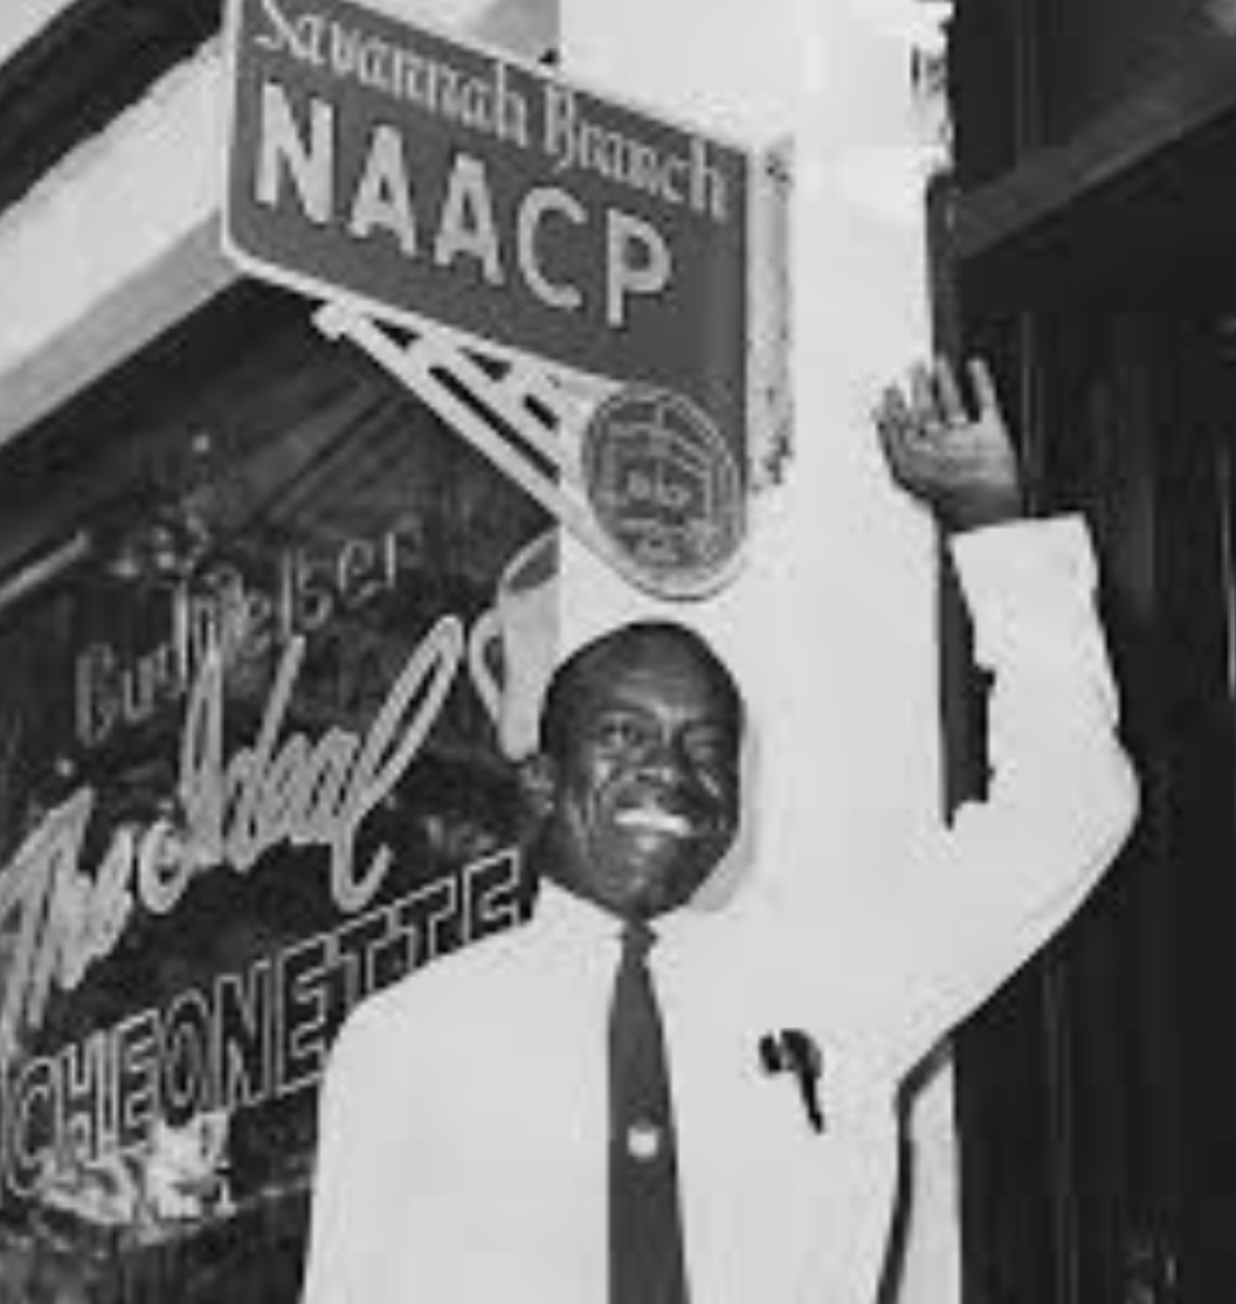
W. W. Law
Craig Keilburger
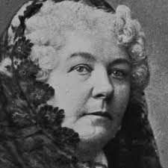
Elizabeth Cady Stanton

