SS.1.E.1.5 Recognize the importance of saving money for future purchases.

SS.1.E.1.6 Identify that people need to make choices because of scarce resources.

Buying and Saving

Photo Credits

People make choices everyday. Sometimes a choice is made because there is not enough of what we want.

* <http://davidewart.typepad.com/.a/6a00d8345310da69e2019b04b89526970d-popup>
* https://www.google.com/search?site=&tbm=isch&source=hp&biw=1280&bih=645&q=decision+making&oq=decision+making&gs_l=img.3..0l10.138202.140967.0.141144.17.13.0.4.4.0.98.685.9.9.0....0...1ac.1.64.img..4.13.711.0.WsGVudQs7lo#tbm=isch&q=scarce+resources+for+kids&imgdii=RtXe1GYhwfk-2M:&imgrc=L43ias6RZ1ZlIM:
* <http://www.qualitywaterservicecompany.com/2011/10/03/save/>
* <https://www.financialsecuritybank.com/community-kids-links.htm>
* <https://www.dreamstime.com/photos-images/piggy-bank-pile-coins.html>
* <http://www.keywordsuggests.com/p3y6iS4Ayn4TJ6lUGZ%7Cha3PaeGAxGBHhR6FHIAFcyII/>
* [https://www.google.com/search?q=one+cent+gum&source=lnms&tbm=isch&sa=X&ved=0ahUKEwiYxKe9xOjTAhXPaCYKHY_4DgcQ_AUICygC&biw=1280&bih=645#imgrc=rrlxD-iOGxAtKM](https://www.google.com/search?q=one+cent+gum&source=lnms&tbm=isch&sa=X&ved=0ahUKEwiYxKe9xOjTAhXPaCYKHY_4DgcQ_AUICygC&biw=1280&bih=645):
* [https://www.google.com/search?site=&tbm=isch&source=hp&biw=1280&bih=645&q=saving+money&oq=saving+money&gs_l=img.3..0l10.2634.4867.0.5404.13.9.0.4.4.0.164.686.7j1.8.0....0...1ac.1.64.img..1.12.707.0.gaaeIuiVPCE#imgrc=HWU7qtDL1A0jCM](https://www.google.com/search?site=&tbm=isch&source=hp&biw=1280&bih=645&q=saving+money&oq=saving+money&gs_l=img.3..0l10.2634.4867.0.5404.13.9.0.4.4.0.164.686.7j1.8.0....0...1ac.1.64.img..1.12.707.0.gaaeIuiVPCE):



2 11

Scarcity can also mean that what we want is no longer available.

Can we buy this right away or do we need to save?

$200

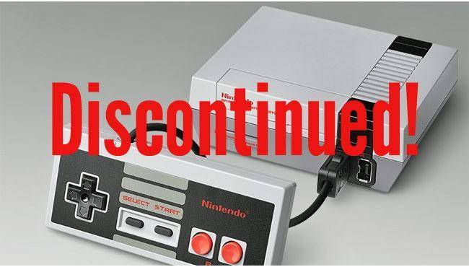 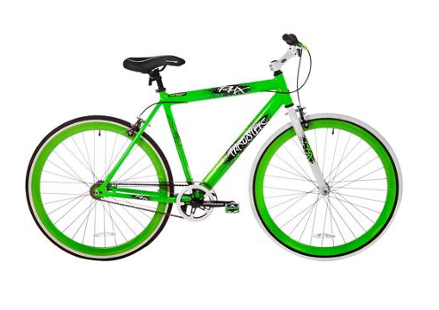

4 9

When we do not have enough of a resource that we want, we say that the resource is scarce.

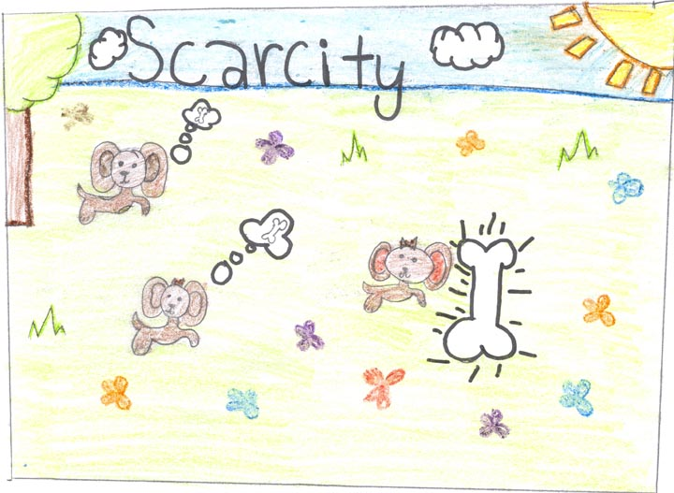

What would you like to save money to buy?

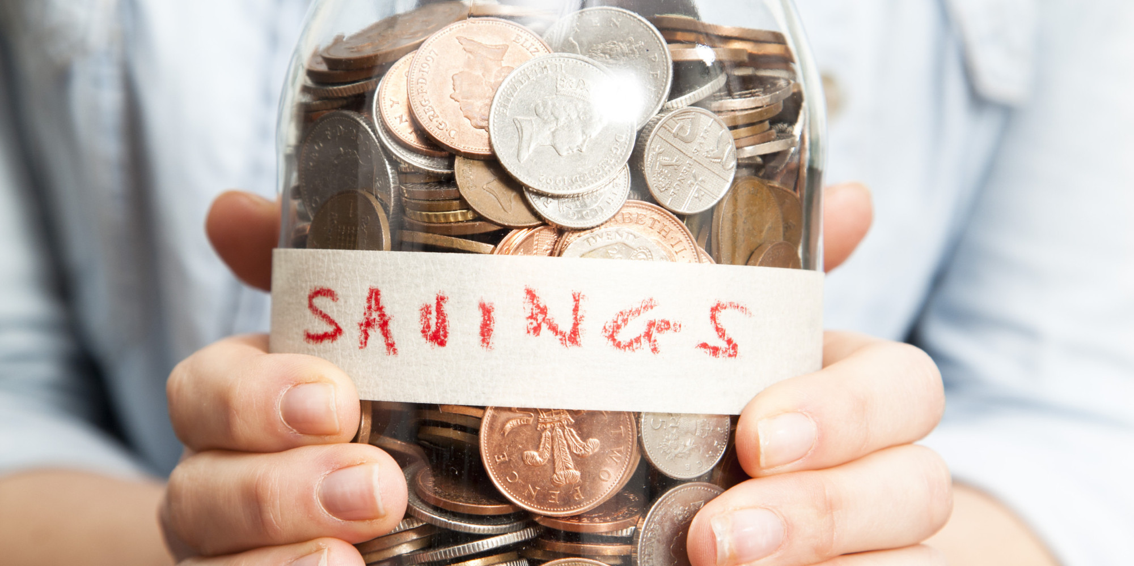

10 3

We can also save money in a bank. Banks pay us a little extra money called interest for letting them use our money until we need it.

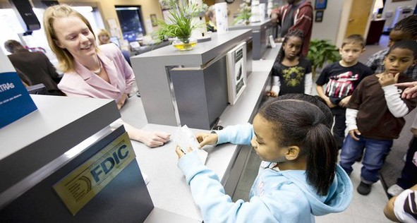

We can save money at home. When we have saved enough money to buy what we want, we can go shopping!



6 7

Sometimes we can buy what we want right away. Sometimes we need to save money to buy what we want.



Can we buy this right away or do we need to save?

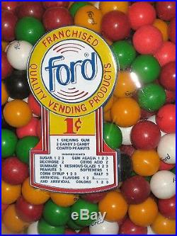

8 5