Photo Credits

* <https://www.usmint.gov/kids/teachers/coinCurricula/>
* <http://www.newmoney.gov>

Coins and Bills

A penny is a coin.

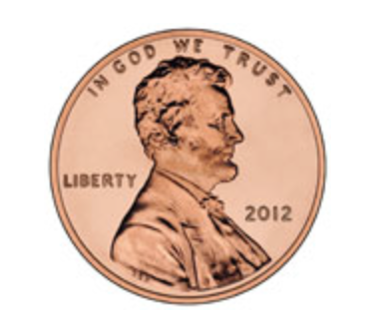

1 cent

1

10

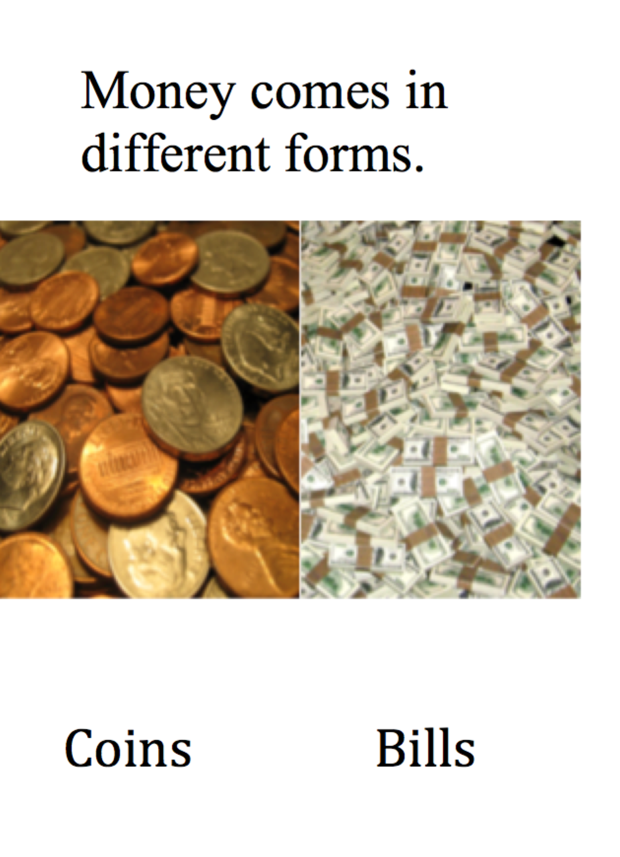

A nickel is a coin.

9

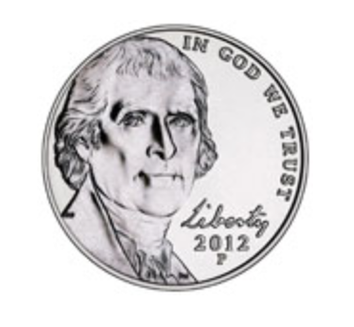

5 cents

2

A dime is a coin.

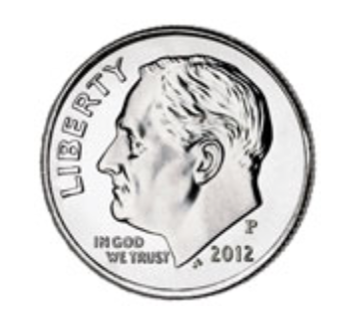

10 cents

3

There are many other types of bills.

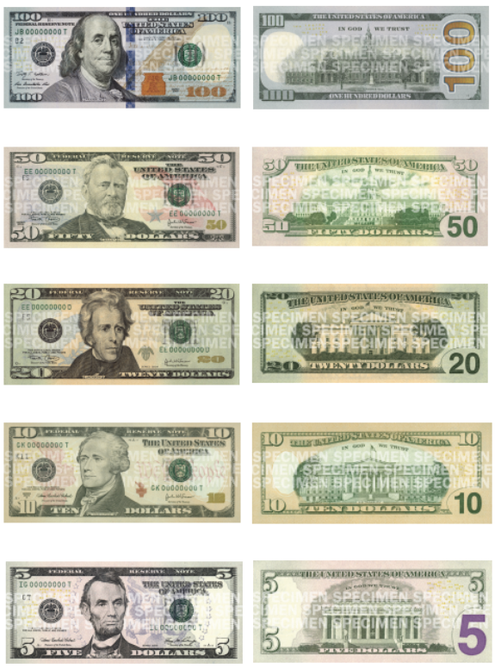

8

A half dollar is a coin.

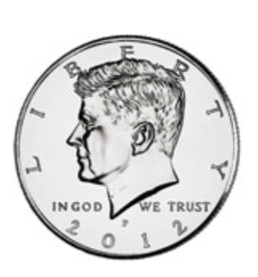

50 cents

5

A dollar is a bill. Bills are made of paper.

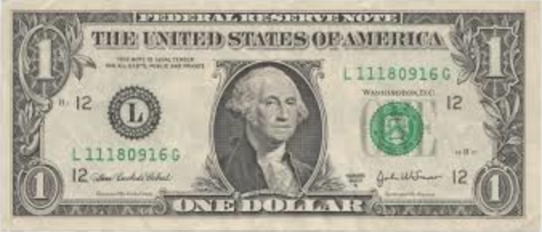

100 cents = 1 dollar

6

A dollar can also be a coin.

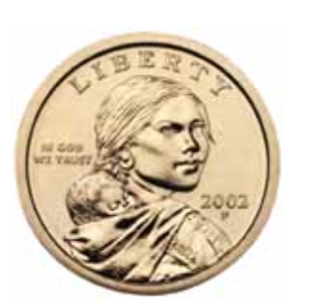

1 dollar

7

A quarter is a coin.

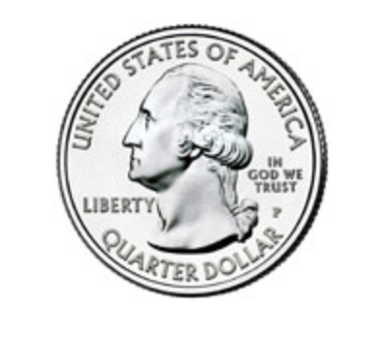

5 cents

4