What Pet Decision-making
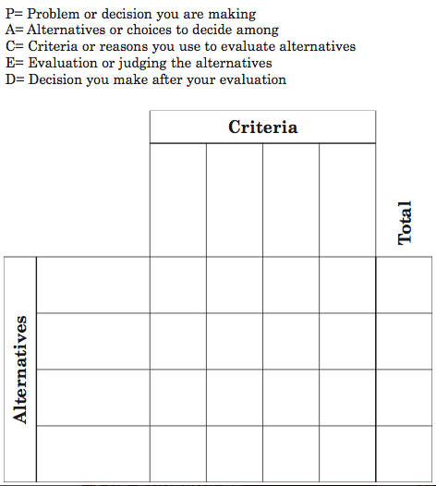

- Before Reading: What problem do they have?
- During Reading: As I read, record the different alternatives or choices they have. Also, record the criteria or reasons why the choices might be good or bad. For example, did Mom or Dad say anything about size, noise, quantity, or price?
- After Reading: Evaluate the alternatives based on criteria found in the story. Choose the best alternative for Kay and her brother. Tell them the reasons why you think this is the best alternative, based on the evidence in the text.

