Standard | Explain Florida's role in the national and international economy and conditions that attract businesses to the state.
Before reading | Project the photograph found at the end of the lesson plan.  What do I See? Ask students what they see in the photograph. Model pointing out a few specific items in the photograph.  What do I Think: Ask students what ideas they have about this photograph. Students may conclude that these are workers at some kind of plant or factory  What do I Wonder: Ask students if they have questions about what is happening in the photo. What does Florida have to do with the countries that are connected on the map?
During reading | Slide 1: Read the title slide. Ask students if they have ever heard the terms national or global economy. Based on the photo they analyzed and previous discussion, what might they think a global economy might be? How would that connect to our national economy?  Slide 2: Read the text. Explain that tourism, as well as citrus, cattle and phosphate, are big industries in Florida and help Florida’s economy grow. Ask what other types of business are important in the community and state. Explain that businesses in Florida are not only important to Floridians, but that many business are part of a bigger picture in doing business with other states and countries.  Slide 3: Read the text. Discuss what ‘technology-related businesses’ means. What kinds of technology do students interact with every day? Note that one of the reasons Florida does so much of this kind of business is the large number of college and university degrees awarded in science and technology.  Slide 4: Read the text. Partner talk: What is an entrepreneur? What types of business might entrepreneurs start (refer to previous lesson on entrepreneurs). Connect Florida’s college and university system from the last slide (technology) to the work these colleges and universities do in supporting entrepreneurs.  Slide 5: Read the text. Partner talk: How does Florida’s geography support the ability to have deep-water ports? What other businesses connect with Florida from other parts of the world?  Slide 6: Read the text. Partner talk: Why does Florida have a so many people who go to college? What do colleges and universities offer that makes people employable?  Slide 7: Read the text. Click on the link to find out more of Florida’s connection to the global economy.
After reading | Read more about why Florida attracts business:  http://www.floridatrend.com/article/6846/top-10-reasons-to-do-business-in-florida?page=4  U.S. Chamber of Commerce: Florida  http://www.2chambers.com/tourist6.htm  Florida and the Global Economy  https://www.theglobalist.com/florida-and-the-global-economy/  Florida Institute for Commercialization of Public Research  http://www.florida-institute.com/  Provide a copy of the text for each student. Practice reading together and with partners.
Resources | Other resources for instruction of this benchmark can be found at Sunny Money: K-8 Economic Resources From the Stavros Center http://sunnymoney.weebly.com/k.html  Learn more about famous Entrepreneurs from Florida at the following websites:  Bright Hub  http://www.brighthub.com/office/entrepreneurs/articles/72828.aspx  Florida Inventors Hall of Fame  http://www.floridainvents.org/  9 Things You Had No Idea Were Invented in Florida  http://www.onlyinyourstate.com/florida/inventions-fl/

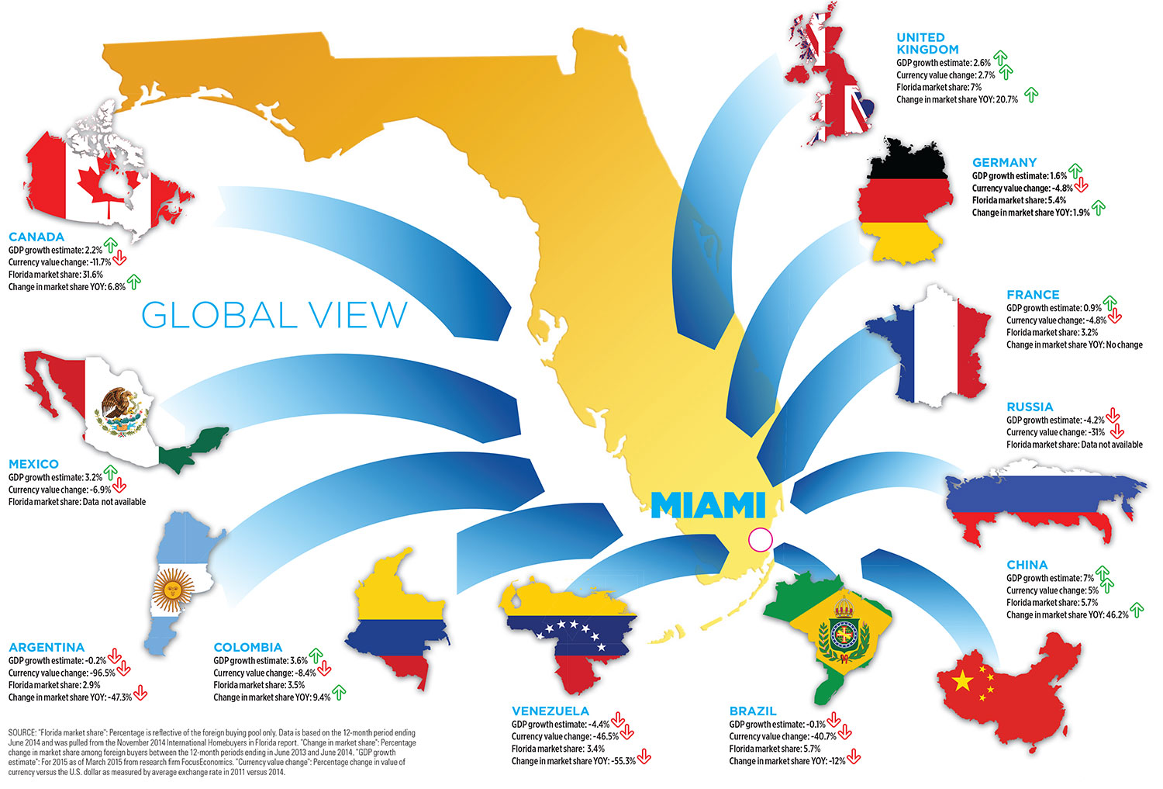

Florida was named the No. 1 state for workforce in CNBC’s 2008 “America’s Top States for Business” study, which rated the workforce in all 50 states on such criteria as education level, number of available workers and relative success of worker training programs in placing participants in jobs.

