What Is Trade?

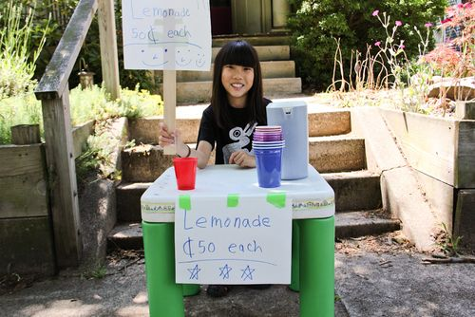

Have you ever swapped sandwiches with a friend at lunchtime? “Trade” is the name we give to any exchange of one thing for something else. Trading can take place between people, companies, and countries.
Trade involves services, money, and goods. Maybe you mowed your neighbor’s lawn, and she paid you. That was trading a service for money. Or maybe you traded your scooter for a friend’s video game. That was trading goods.
People and countries may trade because they have too much of one thing and need something else. For example, in some countries, people grow a lot of rice. They produce more than they need for themselves. That allows them to sell their rice to other countries. The buyers of the rice send money to the sellers. The sellers might use that money to buy goods or services.
Trade allows people to sell, buy, or exchange goods and services to get what they need.

© 2014 ReadWorks®, Inc. All rights reserved.

