Cinderella’s New Shoes Grade 1
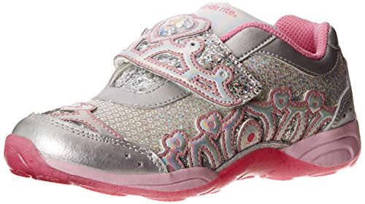
Cinderella wants a new pair of shoes and needs the students' help selecting the right ones for her. Students will work with a team to select the best shoes for Cinderella.
Subject(s): Mathematics, English Language Arts, Social Studies
Grade Level(s): 1
Intended Audience: Educators
Suggested Technology: Document Camera

Instructional Time: 2 Hour(s)
Resource supports reading in content area: Yes
Instructional Component Type(s): Lesson Plan, Problem-Solving Task, Model Eliciting Activity (MEA) STEM Lesson
LESSON CONTENT
- Lesson Plan Template: Model Eliciting Activity (MEA)
- Formative Assessment
The reflective questions and readiness questions can be used as formative assessment throughout the lesson.
- Feedback to Students
Feedback will be given throughout the lesson. Students will receive immediate feedback during group work while the teacher is circulating among the groups.
- Summative Assessment
Students will be assessed on Data Sets and Letter Templates.
Student presentations and group work will be assessed with the summative assessment rubric.
- Learning Objectives
Students will:
  - Describe characters and answer questions about major events in a story.
  - Work collaboratively in groups.
  - Identify numbers less than 45.
  - Identify numbers greater than 45 but less than 75.
- Prior Knowledge
Students need to know how to:
  - Read and interpret a data table.
  - Work cooperatively in a group.
  - Identify numbers to 100.
- Instructional Suggestions
Day 1
1. The teacher will introduce the lesson by asking students how they feel when they get a new pair of shoes. The teacher will ask the students to brainstorm different types of shoes. Students will share which shoes are their favorite and why.

2. The teacher displays and reads aloud a copy of Reading Passage 1 and asks the readiness questions:
  - What is the problem? (Cinderella needs a new pair of shoes)
  - Who is the client? (Cinderella)
  - What is the client asking your team to do? (To help her find a new pair of shoes)
  - What things do you need to include in your solution? (A pair of shoes that are white, blue, or red, have laces, and are less than $45)
  - Do you think there is more than one solution? Why or why not? (Answers may vary)
4. The teacher displays and reads aloud Data Set 1 and gives the class a few minutes to brainstorm individually on ways to solve the problem.
5. The teacher puts students into compatible groups of 3-4.
6. The teacher hands out Data Set 1 to each group. The teacher tells the students to look at the different types of shoes and their prices. The students will write either "greater than" or "less than" in each row to indicate whether the price of the shoe is greater than 45 or less than 45. The teacher circulates around the room while the groups complete Data Set 1. The teacher helps out where needed and asks guiding/reflective questions:
  - What does Cinderella need? Why? (Cinderella needs new shoes because her glass slippers fall of when she runs in them and she likes to run.)
  - How much money does Cinderella have to spend on new shoes? ($45)
  - What are Cinderella's favorite colors? (white, blue, and red)
  - Can Cinderella get shoes with laces? Why or why not? (Yes, because he knows how to tie her shoes.)
7. When the teams solve the problem, students will use Letter Template 1 to write a letter to Cinderella and tell her the shoes they chose and why they chose those shoes.
Day 2
1. The teacher displays and reads aloud a copy of Reading Passage 2.
2. The teacher checks for comprehension of the assignment by asking students the comprehension/readiness questions:
- What is the problem? (Cinderella needs a new pair of shoes)
- Who is the client? (Cinderella)
- What is the client asking your team to do? (To help her find a new pair of shoes)
- What things do you need to include in your solution? (A pair of shoes that are white, blue, or red, have laces can be worn to school, can be worn for running, and are less than $45)
- Do you think there is more than one solution? Why or why not? (Answers may vary)
- What is the least amount Cinderella wants to spend on shoes? ($45)
- What is the greatest amount Cinderella wants to spend on shoes? ($75)
- Can Cinderella get the cowboy boots? Why or why not? (No, they are greater than $75.)
- Can Cinderella get the flip flops? Why or why not? (No, they are less than $45, they cannot be worn to school or for running.)

3. The teacher displays and reads aloud Data Set 2 and gives the students a few minutes to brainstorm individually on ways to solve the problem.
4. The students get into their groups from day 1 and the teacher hands out Data Set 2. The teacher tells the students to circle either "yes" or "no" for each type of shoe indicating whether the price is greater than $45 but less than $75.
5. The teacher circulates around the room while the teams are working and asks Reflection Questions 2:
  - Did you determine which shoes were greater than 45 but less than 75?
  - Did you choose the same shoes after Data Set 2 was introduced?

6. After the teams solve the problem, the students will use Letter Template 2 to write a letter to Cinderella telling her the shoes they chose and why they chose those shoes.
7. When all the teams are finished, they will present their solutions to the class.
- Guiding/reflective Questions
  - What does Cinderella need? Why? (Cinderella needs a new pair of shoes because she likes to run and her glass slippers fall off when she runs.)
  - How much money does Cinderella have to spend on new shoes? ($45)
  - What are Cinderella’s favorite colors? (white, blue, and red)
  - Can Cinderella get shoes with laces? Why or why not? (Yes, she knows how to tie her shoes.)
  - Does it matter how heavy the shoes are? Why or why not? (Heavy shoes may make it harder to run fast)
- Data Set 2 Comprehension/readiness questions
  - What is the least amount Cinderella wants to spend on shoes? ($45)
  - What is the greatest amount Cinderella wants to spend on shoes? ($75)
  - Can Cinderella get the cowboy boots? Why or why not? (No, they are greater than $75)
  - Can Cinderella get the flip flops? Why or why not? (No, they are less than $45)
- Reflection question 2
  - Did you determine which shoes cost more than $45 but less than $75?
  - Were you able to choose the same shoes after Data Set 2 was introduced?
  - Did you agree with the decisions of all of your teammates? Why or why not?
ACCOMMODATIONS & RECOMMENDATIONS
- Accommodations:
  - Read the text of the letters to the students.
  - Display the text or provide a copy of the text for students to read chorally with the teacher.
  - Group students heterogeneously.
  - Use sentence frames for letter writing.
- Extensions:
  - STEM connection: Use a balance to compare and order weight of shoes. Discuss what makes some shoes heavier or lighter. (size of shoe, material it is made from).
  - Economics: Draw and write about examples from the story, using the following economic terms: goods, services, scarcity, opportunity cost, spend, save, costs, benefits, buyers, sellers.
  - Students can sort numbers by less than 50 or greater than 50.
  - Students can create their own design for shoes.
- Suggested Technology: Document Camera and projector

Related Standards
LAFS.1.SL.1.1: Participate in collaborative conversations with diverse partners about grade 1 topics and texts with peers and adults in small and larger groups.
LAFS.1.RI.1.1 Ask and answer questions about key details in a text.

LAFS.1.W.1.2 Write informative/explanatory texts in which they name a topic, supply some facts about the topic, and provide some sense of closure.

MAFS.1.NBT.2.3: Compare two two-digit numbers based on meanings of the tens and ones digits, recording the results of comparisons with the symbols >, =, and <.
SC.1.P.8.1 Sort objects by observable properties, such as size, shape, color, temperature (hot or cold), weight (heavy or light), texture, and whether objects sink or float.
SC.1.N.1.4 Ask "how do you know?" in appropriate situations.
SS.1.E.1.1 Recognize that money is a method of exchanging goods and services.
SS.1.E.1.2 Define opportunity costs as giving up one thing for another.
SS.1.E.1.3 Distinguish between examples of goods and services.
SS.1.E.1.4 Distinguish people as buyers, sellers, and producers of goods and services.
SS.1.E.1.5 Recognize the importance of saving money for future purchases.
SS.1.E.1.6 Identify that people need to make choices because of scarce resources.
SS.1.C.2.1 Explain the rights and responsibilities students have in the school community.
SS.1.C.2.2 Describe the characteristics of responsible citizenship in the school community.
SS.1.C.2.4 Show respect and kindness to people and animals.

Dear Students,

I need your help! I love to run. I am a fast runner, but my glass slippers fall off when I run. I need you to help me pick out a new pair of shoes. White shoes are cool, but I also like the colors blue and red. Also, I just learned how to tie my shoes so shoes with laces are ok. I have $45 to spend on my new shoes. I like to run and I also need to be able to wear the new shoes to school. Please help me find a new pair of shoes that I can be proud of.

When your team finds the pair of shoes for me, write me a letter and tell which shoe you chose and why you chose them.

Your friend,

Cinderella
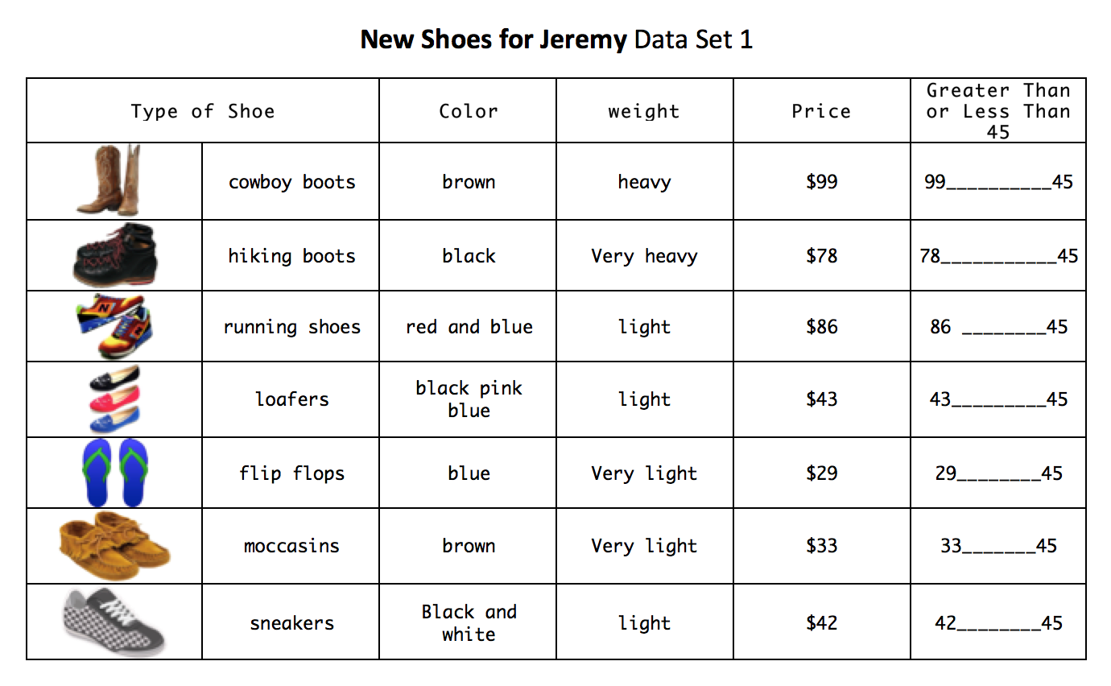
New Shoes for Cinderella Data Set 1

Dear Cinderella,

Our team chose ______________________ as the best shoes for you.

We chose _______________________ because

________________________________________.

Your Friends,

Team _______________

Dear Students,

Thank you for picking out the cool new shoes! I have some good news. My grandma just gave me $30 to add to my $45 so now I have $75 to spend on a new pair of shoes! Please help me find a new pair of shoes with a price greater than $45 but less than $75.

I also found another type of shoes for you to choose from. Also, a couple of the prices on the shoes have changed.

When your team is finished, please write me back and tell me which shoes you chose and how your team made your decision.

Your Friend,

Cinderella

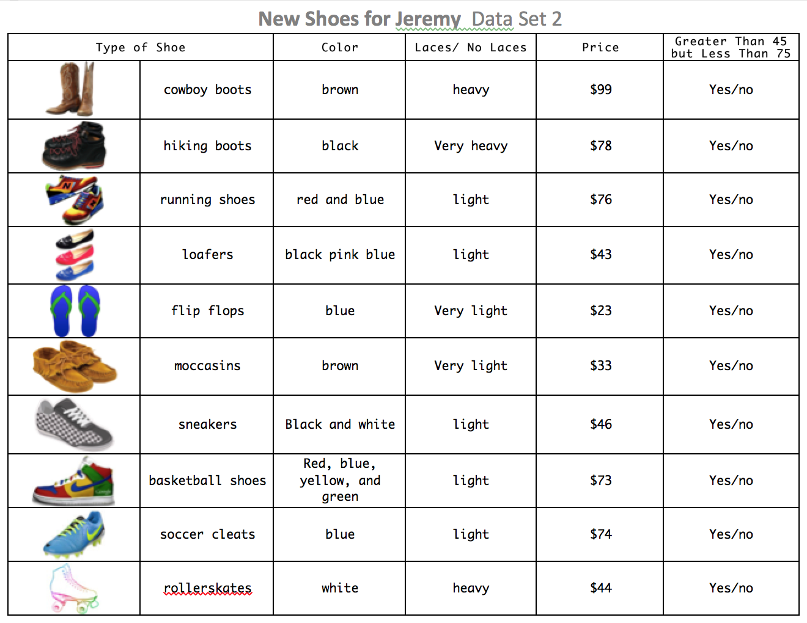
Cinderella’s New Shoes Data Set 2

Letter 2
Dear Cinderella,

After reviewing the new data, our team chose ______________________ as the best shoes for you.

We chose _______________________ because

________________________________________.

Ther (changed/stayed the same) because

Your Friends,

Team _______________
Cinderella’s New Shoes Summative Assessment Rubric Grade 1
 | 4 | 3 | 2 | 1
Working with Others | The student almost always listens to, shares with, and supports the efforts of others. Tries to keep people working well together. | The student usually listens to, shares with, and supports the efforts of others. | The student sometimes listens to, shares with, and supports the efforts of others. | The student rarely listens to, shares with, and supports the efforts of others.
Strategy/  Procedures | The student uses an efficient strategy to solve problems. | The student usually uses an effective strategy to solve problems. | The student sometimes uses an effective strategy to solve problems. | The student rarely uses an effective strategy to solve problems.
Explanation | The explanation is detailed and clear. | The explanation is clear. | The explanation is a little difficult to understand, but includes critical components. | The explanation is not clear or missing.
Presentation | The presentation was clear and detailed. | The presentation was clear. | The presentation was missing some parts of the plan. | The presentation was not clear and was missing many parts of the plan.
Math Comparison | No values incorrectly compared. | 7 to 10 values correctly compared. | 5 to 6 values correctly compared. | 3 or fewer of the values correctly compared.
Economics | Can provide examples using the econ. terms: scarcity, spend, save, costs, benefits, wants, needs, opportunity cost, goods | Can provide examples for most of the economic terms. | Can provide examples for some of the economic terms. | Difficulty using the economic terms.
Civics | Can pick out and evaluate examples of good citizenship. | Can pick out and evaluate some examples of good citizenship. | Can pick out examples of good citizenship. | Has difficulty providing examples of good citizenship.

Total points ________/28

