Cinderella’s New Shoes
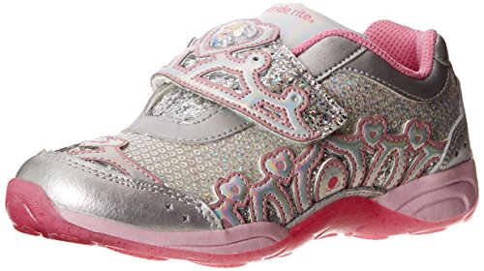
Cinderella wants a new pair of shoes and needs the students' help selecting the right ones for her. Students will work with a team to select the best shoes for Cinderella.
Subject(s): Mathematics, English Language Arts
Grade Level(s): 2
Intended Audience: Educators
Suggested Technology: Document Camera
Instructional Time: 2 Hour(s)
Resource supports reading in content area: Yes
LESSON CONTENT
- Lesson Plan Template: Model Eliciting Activity (MEA)
- Formative Assessment
The reflective questions and readiness questions can be used as formative assessment throughout the lesson.
- Feedback to Students
Feedback will be given throughout the lesson. Students will receive immediate feedback during group work while the teacher is circulating among the groups.
- Summative Assessment
Students will be assessed on Data Set 2 and Letter Template 2.
Student presentations and group work will be assessed with the summative assessment rubric.
- Learning Objectives
Students will:
  - Skip-count by 10s.
  - Explain why addition and subtraction strategies work, using place value and the properties of operations.
  - Ask and answer such questions as who, what, where, when, why, and how to demonstrate understanding of key details in a text.
  - Identify the main purpose of a text, including what the author wants to answer, explain, or describe.
  - Observe and measure objects in terms of their properties, including size, shape, color, and weight.
  - Work collaboratively in groups.
  - Recognize that people make choices because of scarce resources.
  - Explain the costs and benefits of saving and spending.
  - Describe characteristics of responsible citizenship and identify ways citizens make positive contributions.
- Prior Knowledge
Students need to know how to:
  - Read and interpret a data table.
  - Work cooperatively in a group.
- Instructional Suggestions
Day 1
The teacher will introduce the lesson by asking students how they feel when they get a new pair of shoes. The teacher will ask the students to brainstorm different types of shoes. Students will share which shoes are their favorite and why.
The teacher displays and reads aloud a copy of Reading Passage 1 and asks the readiness questions:
  - What is the problem? (Cinderella needs a new pair of shoes)
  - Who is the client? (Cinderella)
  - What is the client asking your team to do? (To help her find a new pair of shoes)
  - What things do you need to include in your solution? (A pair of shoes that are white, blue, or red, can be worn to school, can be worn while walking dogs, can be worn to run and play, and can be bought by Cinderella as soon as possible)
  - How much money is Cinderella going to earn each week?
  - How is Cinderella going to earn the money?
  - When will she be able to buy her new shoes?
  - How much money will she have in two weeks? Three weeks? Etc.
  - How many weeks will Cinderella have to work to buy a pair of shoes that costs $46? How do you know? (Ask the same question with different amounts of money: $25, $81, $45, $19
  - Why does the weight of a shoe matter?
  - Do you think there is more than one solution? Why or why not? (Answers may vary)
4. The teacher displays and reads aloud Data Set 1 and gives the class a few minutes to brainstorm individually on ways to solve the problem.
5. The teacher puts students into compatible groups of 3-4.
6. The teacher hands out Data Set 1 to each group. The teacher tells the students to look at the different types of shoes and their prices. The students will write the number weeks it will take Cinderella to earn enough money to buy each pair of shoes. The teacher circulates around the room while the groups complete Data Set 1. The teacher helps out where needed and asks guiding/reflective questions:
7. When the teams solve the problem, students will use Letter Template 1 to write a letter to Cinderella and tell her the shoes they chose and why they chose those shoes.
Day 2
1. The teacher displays and reads aloud a copy of Reading Passage 2.
2. The teacher checks for comprehension of the assignment by asking students the comprehension/readiness questions:
  - What is the least amount Cinderella could spend on shoes? How soon could he get those shoes?
  - Would the shoes he can afford the soonest be good shoes for her to get? Why or why not?
  - Should Cinderella get the cowboy boots? Why or why not?
3. The teacher displays and reads aloud Data Set 2 and gives the students a few minutes to brainstorm individually on ways to solve the problem.
4. The students get into their groups from day 1 and the teacher hands out Data Set 2. The teacher tells the students to circle either "yes" or "no" for each type of shoe indicating whether the price is greater than $45 but less than $75.
5. The teacher circulates around the room while the teams are working and asks Reflection Questions 2:
  - Did you determine how long it would take for Cinderella to save up for the new shoes? What strategies did you and your teammates use to figure this out?
  - Were you able to choose the same shoes after Data Set 2 was introduced?
6. After the teams solve the problem, the students will use Letter Template 2 to write a letter to Cinderella telling her the shoes they chose and why they chose those shoes.
7. When all the teams are finished, they will present their solutions to the class.
- Comprehension/readiness questions
- How will having an addition $30 change how long it will take for Cinderella to save up for the new shoes?
- How can you figure out how long it will take Cinderella to have enough money to buy the shoes now?
- What are some different strategies we can use to figure out how long it would take Cinderella to have enough money for new shoes?
- Reflection question 2
  - Did you choose the same shoes after Data Set 2 was introduced? Why or why not?
  - Did you use the same system to choose shoes the second time?
  - Did you agree with the ideas of all of your team mates? If not, did you find a way to come to a consensus?

- Supplemental Reading
Those Shoes by Maribeth Boelts
About This Book
All Cinderella wants is a pair of those shoes like the ones everyone at school seems to be wearing. Though Cinderella's grandma says they don't have room for "want," just "need," when his old shoes fall apart at school, he is more determined than ever to have those shoes, even a thrift-shop pair that's the wrong size. But sore feet aren't much fun, and Cinderella soon sees that the things he has — warm boots, a loving grandma, and the chance to help a friend — are worth more than the things he wants.
Lexile level 680

ACCOMMODATIONS & RECOMMENDATIONS
- Accommodations:
  - Read the text of the letters to the students.
  - Display the text or provide a copy of the text for students to read chorally with the teacher.
  - Group students heterogeneously.
  - Use sentence frames for letter writing.
- Extensions:
  - Students can create their own design for shoes.
  - Students can use advertisements with shoes and prices to find more shoe options.
  - ECON: Students can interview their classmates, friends, and family about their shoe decisions. What shoes did you recently buy? Why did you choose those shoes? What made you choose those shoes over another pair?
  - STEM connection: Have students weigh their shoes and write the weight on a slip of paper or sticky note. Arrange the shoes by weight. Discuss what makes some shoes heavier or lighter. (size of shoe, material it is made from). Or use a balance to compare and order weight of shoes.
- Suggested Technology: Document Camera and projector

Related Standards
MAFS.2.NBT.1.2 Count within 1000; skip-count by 5s, 10s, and 100s.
MAFS.2.NBT.2.9 Explain why addition and subtraction strategies work, using place value and the properties of operations.
LAFS.2.RI.1.1 Ask and answer such questions as who, what, where, when, why, and how to demonstrate understanding of key details in a text.
LAFS.2.RI.2.6 Identify the main purpose of a text, including what the author wants to answer, explain, or describe.
LAFS.2.SL.1.1 Participate in collaborative conversations with diverse partners about grade 2 topics and texts with peers and adults in small and larger groups.
LAFS.2.W.1.2 Write informative/explanatory texts in which they introduce a topic, use facts and definitions to develop points, and provide a concluding statement or section.
SC.2.P.8.1 Observe and measure objects in terms of their properties, including size, shape, color, temperature, weight, texture, sinking or floating in water, and attraction and repulsion of magnets.
SS.2.E.1.1 Recognize that people make choices because of limited resources.
SS.2.E.1.2 Recognize that people supply goods and services based on consumer demands.
SS.2.E.1.4 Explain the personal benefits and costs involved in saving and spending
SS.2.C.2.2 Define and apply the characteristics of responsible citizenship.

Dear Students,

I need your help! I love to run but my glass slippers fall off when I run. I just got a job walking dogs and will be able to buy myself a cool new pair of shoes. I will be paid $10 every week starting this week. When I have enough money to buy shoes I will get them.
I need you to help me pick out my new pair of shoes. White shoes are cool, but I also like the colors blue and red. Also, I just learned how to tie my shoes so shoes with laces are ok. I need shoes that I can wear to school and run and play in. I would like to get them as soon as I can. Please help me find a new pair of shoes that I can be proud of.

When your team finds the pair of shoes for me, write me a letter and tell which shoe you chose and why you chose them.

Your friend,

Cinderella
New Shoes for Cinderella
Type of Shoe |  | Color | Weight | Price | How many weeks will it take to be able to buy them?
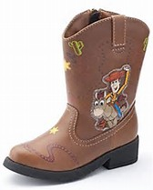 | cowboy boots | brown | heavy | $99
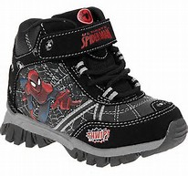 | hiking boots | black | Very heavy | $78
 | running shoes | White and pink | light | $86
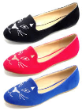 | loafers | Black,red,or blue | light | $43
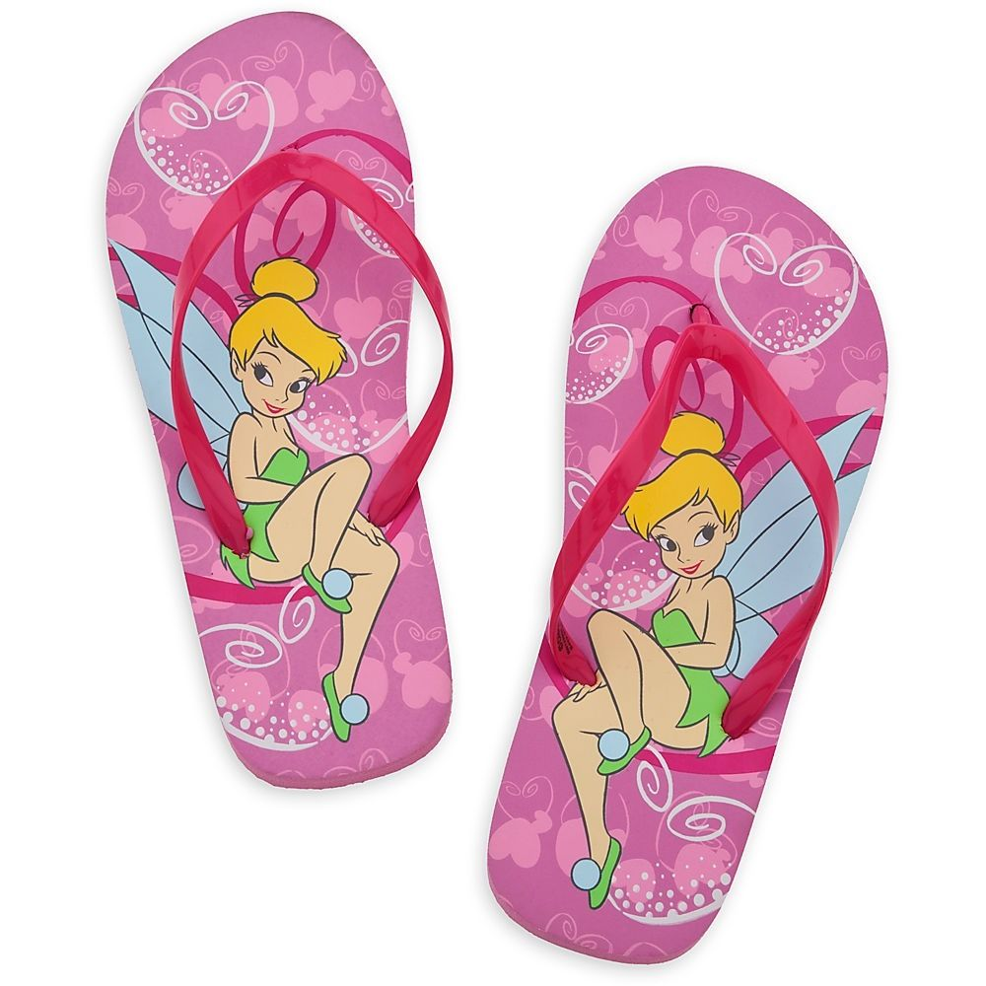 | flip flops | Pink or blue | Very light | $29
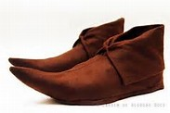 | Peter Pan moccasins | brown | light | $42
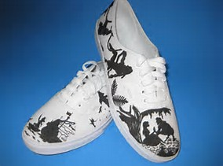 | sneakers | Black and white | light | $33

Dear Cinderella,
Our Team, ________________________, has reviewed all of the data provided by you and created a list in order from "best to worst" of shoes that are best for you. The order is as follows:

We chose _______________________because:
_______________________________________
The procedure we used to determine the order was:

Yours truly,

Passage 2
Cinderella Jones
1150 Main Street
Tampa Fl 33355

Dear Students,
Thank you for picking out the cool new shoes! I have some good news. My grandma just gave me $30 to add to the money I am earning! Now I will be able to buy my shoes sooner!

I found another type of shoes for you to choose from. Also, a couple of the prices on the shoes have changed.

When your team is finished, please write me back and tell me which shoes you chose and how your team made your decision.

Your Friend,

Cinderella
New Shoes for Cinderella
Type of Shoe |  | Color | Weight | Price | How many weeks will it take to be able to buy them?
 | cowboy boots | brown | heavy | $89
 | hiking boots | black | Very heavy | $78
 | running shoes | Pink and white | light | $86
 | loafers | Black, red, or blue | light | $43
 | flip flops | Pink or blue | Very light | $29
 | Peter Pan moccasins | brown | light | $52
 | sneakers | Black and white | light | $36
 | basketball shoes | Red, yellow, blue, and green | light | $63
 | running shoes | Red and white | light | $83

Dear Cinderella,
Our Team, ________________________, has reviewed all of the new data. This is our rank from best to worst:

We chose _______________________because:
_______________________________________

The procedure we used to determine the order was:

This was similar/different from our first choice because:

Yours truly,

Cinderella’s New Shoes Summative Assessment Rubric – Grade 2
 | 4 | 3 | 2 | 1
Working with Others | The student almost always listens to, shares with, and supports the efforts of others. Tries to keep people working well together. | The student usually listens to, shares with, and supports the efforts of others. | The student sometimes listens to, shares with, and supports the efforts of others. | The student rarely listens to, shares with, and supports the efforts of others.
Strategy/  Procedures | The student uses an efficient strategy to solve problems. | The student usually uses an effective strategy to solve problems. | The student sometimes uses an effective strategy to solve problems. | The student rarely uses an effective strategy to solve problems.
Explanation | The explanation is detailed and clear. | The explanation is clear. | The explanation is a little difficult to understand, but includes critical components. | The explanation is not clear or missing.
Presentation | The presentation was clear and detailed. | The presentation was clear. | The presentation was missing some parts of the plan. | The presentation was not clear and was missing many parts of the plan.
Math | Student is able to solve all problems correctly | Getting it -5 to 6 correctly solved. | Starting to get it -3 to 4 problems correctly solved | Student is not yet able to solve this type of problem.
Social Studies | Student is able to evaluate choices, make decisions and explain reasons. | Student is able to evaluate choices and make decisions. | Student has some difficulty evaluating choices and making decisions. | Student is unable to evaluate choices.

Total points ________/20

