**Cinderella’s Shoes**  
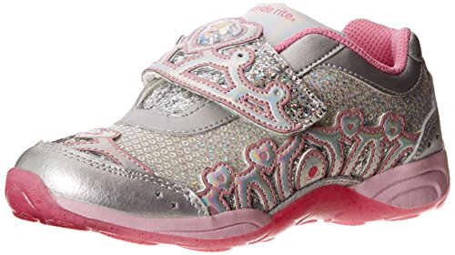



In this lesson, your students will enjoy learning how to compare fractions and use that mathematical knowledge to create an inventory for Cinderella’s new shoe store. They will also write to express their opinions and provide reasons to justify their opinions.

**Subject(s):** Mathematics, English Language Arts

**Grade Level(s):** 3

**Suggested Technology:** LCD Projector

**Instructional Time:** 3 Hour(s)

**Resource supports reading in content area:** Yes

**Keywords:** fraction, fractions, equivalent fractions, comparing fractions, opinions, reasons, evidence, percent, percentage

**LESSON CONTENT**

* **Formative Assessment**

Teacher will provide students with some practice problems (answer keys also included for teacher use) in order to assess prior knowledge.

Fractions Practice:  
[Comparing Fractions - Relative Size](http://www.commoncoresheets.com/Math/Fractions/Comparing%20Fractions%20Relative%20Size/English/1.pdf)  
[Fraction of Whole Visual](http://www.commoncoresheets.com/Math/Fractions/Fraction%20of%20Whole%20Visual/English/1.pdf)

Data Knowledge Practice:  
[Reading a Bar Graph - 5 Bars](http://www.commoncoresheets.com/Math/Bar%20Graphs/5%20Bars/English/1.pdf)

Throughout the lesson, the teacher will observe and listen to the strategies that the students are using. Teacher will use a question and answer period to see where the students are as far as their understanding of comparing fractions and their reasoning.

* **Feedback to Students**

The students will have the opportunity to ask clarification questions throughout the individual and group process. The teacher will observe and monitor student understand and clarify/guide when appropriate. The students will be given feedback upon receiving their letters to help "keep them on the right track."

* **Summative Assessment**

The teacher will determine the students' understanding of the standards by combining the work of individual and group activities. The students will work individually and in collaborative groups to create the letters and mathematical data and to present their information to the class.

Please see the Cinderella’s Shoe Store rubric.

* **Learning Objectives**
  + The students will be able to solve problems based on their ability to correctly compare fractions.
  + The students will write to express their opinions, providing logical reasoning.
* **Prior Knowledge**
  + Knowledge of simple fractions
  + Definition of numerator and denominator
  + How to read and understand data from a table
* **Instructional Suggestions**

1. Read Client Letter 1/ **Reading Passage 1** to class.
2. Begin by asking the readiness questions. This will allow you to provide support/guidance in order to get students on track.

**Reading Passage 1** **Readiness Questions**

* + Who is the client and what is the client asking you to do? (Cinderella’s Shoes Footwear. They want us to use the data provided to create an inventory list based on comfort, durability, appeal, cost to the consumer, and inventory sold. They also want us to use fractions to represent the quantities of each type of shoe.)
  + What information do you need to have to make your decisions? (We need to use the data to decide what factors are most important to making our decisions. We also need to understand fractions to be able to understand and interpret the inventory sold.)
  + Why do they want us to look at their data from last year's sales? (We need to see how many of each type of shoe was sold and how many were left over to give us a guideline for about how many shoes they will need to order this year without having so many shoes left over in unsold inventory.)
  + What will happen if the store loses money? (It will have to close)

1. Divide the class into groups of 4 or 5 depending on how many students you have. Have groups decide on a team name.
2. Distribute **"Reading Passage 1** Cinderella’s MEA" to each group. Give them a few minutes to read the first letter within their groups. Allow students to have a preliminary discussion about the problem within their groups.
3. Distribute "**Data Set 1** Cinderella’s MEA" to each group. Give them a few minutes to read and process the information.
4. Allow time for them to have further discussion within their groups using the guiding/reflective questions as a guide. You can project the questions if you have a Smartboard or projector or give them a copy of the questions.
5. **Data Set 1** **Comprehension/readiness questions**
   * How will you use math to compare the customer reviews and the data of inventory sold?
   * What process did you use to compare each row of data?
   * How will you compare the fractions in the inventory data row since their denominators are different?
   * What did you do with the fractions?
6. Give the students paper and pencils to begin their work on problem solving. Remind the class that there will be several different ways to answer the client and they should use different math strategies and their knowledge of fractions in order to solve the problem.
7. Have teams work on their letter to the company. You may choose to have them use "Letter Template 1 Cinderella’s Shoes" or have them come up with their own response entirely. You may also choose to have them work as a team or individually depending on how you would like to assess their writing and fractions.

Day 2 (60 minutes)

1. Congratulate students on their hard work in solving the problem!
2. Distribute the second letter (twist) "**Reading Passage 2** Cinderella’s Shoes MEA."
3. Distribute the "**Data Set 2** Cinderella’s Shoes MEA" to the students. Provide them with the reflection questions using a Smartboard, projector, or copy. Provide support and feedback to the teams by visiting and going over the reflection questions. Encourage the students to keep working towards the solution. Remind them that there will be several ways to address this problem. Provide support to the teams that showed weakness in specific areas (fractions, opinions, reasons) according to the letters from Day 1.

**Guiding/reflective Questions**

* + What specific things must you think about when deciding on the shoe inventory?
  + How can we figure out how many shoes to order of each type?
  + What math strategies can we use to give the client the data they need?

1. Have teams work on their final letter to the company. You may choose to have them use "Letter Template 2 Cinderella’s Shoes" or have them come up with their own response entirely. You may also choose to have them work as a team or individually depending on how you would like to assess their writing and fractions).

**Letter Template 2** **Reflection questions**

* + What changes to your solution, if any, did you have to make?
  + What would you do differently next time?

1. Allow students time to work on how they will present this information to the class on Day 3.

The presentation should include:

* + 1. How they interpreted their data (what they felt was most important)
    2. What the fractions meant and how they converted them to make sense of the numbers
    3. What system they used to come up with the inventory (number scale, points system, random)
    4. Final reasoning and data they provided to the company (can be displayed in the form of a chart, table, list, etc.)

Day 3 (60 minutes)

Class Presentations

Use "**Student Rubric Cinderella’s Shoes MEA**" to grade each student as they present

**ACCOMMODATIONS & RECOMMENDATIONS**

* **Accommodations:** 
  + Mixed grouping
  + Place students with varying math levels on a team
* **Suggested Technology:** LCD Projector and document camera
* **Extensions:** 
  + Students can convert fractions from the data sets to percentages. For example: 9/10 = 90%. 90% of school shoes were sold in 2013.
  + You may also ask students to provide percentages of shoes for the inventory. For example: 45% percent of the inventory will be for sandals, etc.
  + As a writing extension activity, you can have the students complete a journal writing activity in class in which they are asked to explain **their own** favorite type of shoe and give reasons to support their opinions.
  + As a creative activity, ask the students to explain why Jeremy didn’t like the shoes he chose out of the box. What other choices could he have made to solve his problem? Lead the students toward identifying the animal logo on the shoes as the biggest problem. Ask them how he could have made the shoes cool. Imagine if Jeremy would have designed something really cool on his shoes and other students decided they wanted cool shoes also. Could he have become an entrepreneur and developed his own recycled shoes? Tell the students to design a pair of cool shoes, using a logo of something they like.

**Associated Standards:**  
MAFS.3.NF.1.1.3.b: Explain equivalence of fractions in special cases, and compare fractions by reasoning about their size. Recognize and generate simple equivalent fractions, e.g., 1/2 = 2/4, 4/6 = 2/3). Explain why the fractions are equivalent, e.g., by using a visual fraction model.

[LAFS.3.RI.1.1](http://www.cpalms.org/Public/PreviewStandard/Preview/5756) Ask and answer questions to demonstrate understanding of a text, referring explicitly to the text as the basis for the answers.

[LAFS.3.RI.3.7](http://www.cpalms.org/Public/PreviewStandard/Preview/5762) Use information gained from illustrations (e.g., maps, photographs) and the words in a text to demonstrate understanding of the text.

[LAFS.3.W.1.1:](http://www.cpalms.org/Public/PreviewStandard/Preview/5823) Write opinion pieces on topics or texts, supporting a point of view with reasons.

[LAFS.3.SL.1.1](http://www.cpalms.org/Public/PreviewStandard/Preview/5870)Engage effectively in a range of collaborative discussions with diverse partners on grade 3 topics and texts, building on others’ ideas and expressing their own clearly.

[MAFS.3.NF.1.1:](http://www.cpalms.org/Public/PreviewStandard/Preview/5367) Understand a fraction 1/b as the quantity formed by 1 part when a whole is partitioned into b equal parts; understand a fraction a/b as the quantity formed by a parts of size 1/b.

SS.3.E.1.1 Give examples of how scarcity results in trade.

SS.3.E.1.3 Recognize that buyers and sellers interact to exchange goods and services through the use of trade or money.

SS.3.C.2.1 Identify group and individual actions of citizens that demonstrate civility, cooperation, volunteerism, and other civic virtues.

**Cinderella’s Shoes Footwear**



Dear Students,

It has been brought to our attention that there is a need for a store that sells affordable, high quality shoes at low prices. Many families cannot afford the high prices of sports specialty stores and department stores.

Our company sells three types of shoes (sandals, sneakers, school shoes) to be used for all kinds of activities. Buying large quantities of only a few types of shoes allows us to sell only the best brands at the lowest possible prices.

Our new store is opening in Tampa, Florida and has hired you to create an inventory list of different types of shoes for their grand opening. We want you to look at our customer reviews and the types and amounts of shoes that have been sold. We want to have 300 shoes in our inventory. You will need to make a list of shoes and determine how many of each type of shoe should be ordered. Comfort, durability, appeal, and cost to the consumer are all important to us since we want our customers to come back and shop again! We also do not want to have a lot of inventory left over because if we do the store will be losing money!

Our goal is to provide cool, comfortable shoes that kids will like and all parents can afford to buy.

We have put important information on the next page. Please write me back to let me know what inventory the store should have for their grand opening and how you created the inventory. Please write the number and the fraction for each type of shoe along with your reasons.

Thank you!

Cinderella’s Shoes Footwear

Data Set 1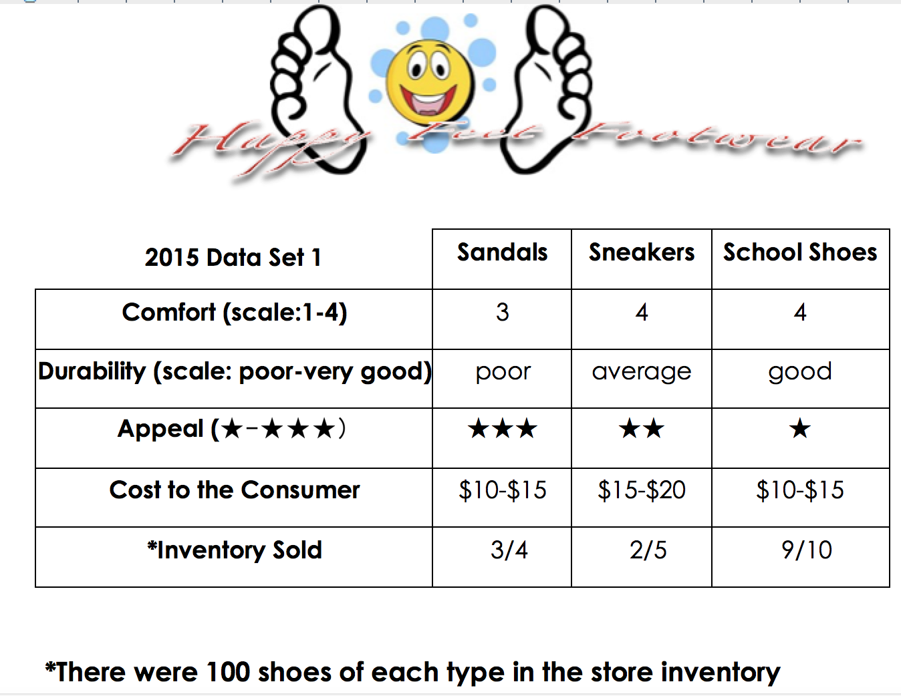

**Cinderella’s Shoes**



Dear Cinderella’s Shoes Footwear,

Our team, _______________________________, has determined that the ______________________ is the best shoe for your store.

We chose these as the best shoe because:

Our procedure for determining the order of our ranking:

Sincerely,

Reading Passage 2

**Cinderella’s Shoes Footwear**

Dear Students,

Thank you so much for creating the inventory for our client’s grand opening! Great news! Cinderella’s Shoes Footwear has just added a fourth type of shoe to sell in our Tampa store. We feel that customers in Tampa would like to buy boots for cold weather days and trips to colder climates! Please recalculate your inventory to include boots in the stores’ grand opening. To include the boots, we will increase our inventory to 350. Remember that comfort, durability, appeal, and cost to the consumer are all important to our client and they do not want to have a lot of inventory left over because the store will be losing money!

We have put the new information on the next page. Write me back to let me know what inventory the store should have for our grand opening and how you created the inventory. Remember to write the number and the fraction for each type of shoe along with your reasons.

Thank you!

Cinderella’s Shoes Footwear

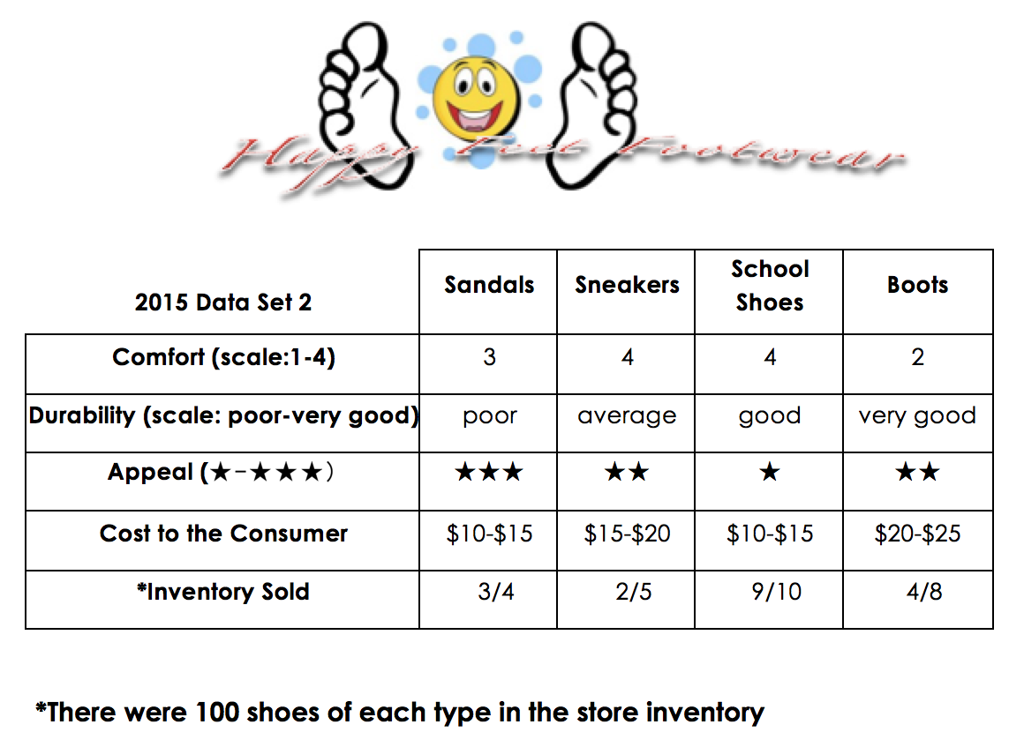

**Cinderella’s Shoes**



Dear Cinderella’s Shoes,

Using all the new information as well as the old, our team, _______________________________, has determined that the ______________________ is the shoe. Below, please find the ranking for the other shoes.

_________________________

Our procedure for determining the order of our ranking is below.

Some new information that we considered was__________________________________________________________________

Sincerely,

STUDENT RUBRIC

**Math Language Arts Team Collaboration__**

|  |  |  |  |
| --- | --- | --- | --- |
| **A** | Demonstrating **complete understanding** of fractions and how they compare and convert | Writes letters with **several** reasons to **clearly and effectively** support opinions | Student is **fully** engaged with speaking and listening in the activity |
| **B** | Demonstrating **a good deal of understanding** of fractions and how they compare and convert | Writes letters with **a few** reasons to support opinions | Student is **frequently** engaged, speaking and listening in the activity |
| **C** | Demonstrating **some understanding** of fractions and how they compare and convert | Writes letters with **only 1** reason to support opinion | Student is **occasionally** speaking and listening in the activity |
| **D** | Demonstrating **little understanding** of fractions and how they compare and convert | Writes letters **without** providing any reasoning or reasoning does not make sense | Student gives **little** input or feedback to other members of the team during the activity |
| **F** | Student is not putting forth any effort to solve problems posed by client | **Does not** write letters at all or does not provide opinions or support | Student **does not** give input or feedback during the activity and does not appear to be listening. |