Cinderella’s Shoe Store

Students will work in collaborative groups to solve multi-step problems with whole numbers and decimals by using different mathematical operations of addition, subtraction, and multiplication. The students will be asked to assist a discount shoe store owner, who is planning a one day sale promotion, to choose a famous brand sneaker to feature for the one day sale. Students will determine which one will bring in more customers, as well as provide the most profit. Students will read a data table, rank the famous brand sneakers from 1-6, calculate the total profit margin per pair, and the total sales potential profit margin determined by the number of sneakers in stock. A twist is added to the problem when additional stock items are added, plus one of the brands is removed and two new brands are added.

**Subject(s):** Mathematics, English Language Arts

**Grade Level:** 4

**Suggested Technology:** Basic Calculators

**Instructional Time:** 2 Hour(s)

**LESSON CONTENT**

* **Lesson Plan Template:** Model Eliciting Activity (MEA)
* **Formative Assessment**

The comprehension, readiness, and reflection questions can be used as formative assessment. They should give an indication of whether the students understand the problem and the problem context. If needed, the teacher may review examples of borrowing with subtraction and multiplication before beginning the lesson. The data table should be discussed and reviewed with the students. They should also elicit students' thinking and conversation as they're working in groups. The teacher can discuss the readiness/comprehension questions with the students before they begin working with the data. After the students read the first client letter, they can respond to the comprehension questions. The reflective questions can be asked by the teacher as the students are working in their groups. The students' responses will provide an indication of any misunderstandings so the teacher can then clarify them.

A brief pretest and answer keys are included:

[Subtraction and Multiplication Pretest](http://www.cpalms.org/Uploads/resources/70490/Assessment/FormativeAssessment/docs/Subtraction%20and%20Multiplication%20Pretest.docx)

[Subtraction and Multiplication Pretest (Answer Key)](http://www.cpalms.org/Uploads/resources/70490/Assessment/FormativeAssessment/docs/Subtraction%20and%20Multiplication%20Pretest%20(Answer%20Key).docx)

* **Feedback to Students**
  + The students can receive feedback from the teacher at any time during the lesson.
  + Before the problem, students will receive feedback in the form of a teacher-led discussion reviewing answers to the subtraction and multiplication lesson.
  + The teacher can give clarification or feedback during group discussions.
  + After the students have worked on their 1st and/or 2nd client letter, the teacher or the students can give feedback to their solutions.
  + The feedback can be used to go back and improve their responses.
  + Students will receive feedback after completing the problem in the form of a final grade.
* **Summative Assessment**
  + The teacher will gather information about the students' understanding and prior knowledge through discussions especially through the guided, reflection, and comprehension questions.
  + Also, the teacher can check the math calculations.
  + The Writing Rubric can be used to assess the Writing Objectives.
* **Learning Objectives**

The students will:

* + Read and interpret a data table.
  + Write to make suggestions and justify them.
  + Correctly calculate costs using mathematical operations.
  + Add, subtract, and multiply decimals with money equivalents to solve a real-world problem.
  + Collaborate in cooperative teams to solve open-ended problems.
  + Write an opinion piece to support opinions with text-based evidence, and demonstrate the ability to introduce a topic clearly, state an opinion, and create an organizational structure.
  + Demonstrate command of conventions of standard English using correct grammar to write a letter.
* **Prior Knowledge**

The students will:

* + Write to a specific purpose and audience.
  + Read and interpret a data table.
  + Write to make suggestions and justify them.
  + Correctly calculate costs using mathematical operations.
  + Correctly add, subtract, and multiply decimals with money notations.
  + Collaborate in cooperative teams to solve open-ended problems.
  + Demonstrate command of conventions of standard English using correct grammar to write a letter.
* **Instructional Suggestions**

**Part 1 (Day 1)**

* + Have students work through the examples of subtracting and multiplying decimals with money notations and provide a review if needed (see Formative Assessment).
  + Students receive client letter 1 (**Cinderella’s Shoe Store Client passage 1**, 1230L, teachers may choose to read this passage to the class) and (**Cinderella’s Shoe Store Data 1**).
  + Afterwards, lead a class discussion focused on clarifying confusing vocabulary from any of the client letters.
  + Discuss the readiness/comprehension questions with the class.
* **Readiness Questions**
  + What is the problem? (Answer: Client needs to select the best Famous Brand Sneakers to discount for a One Day Sale.)
  + Who is the client? (Answer: Cinderella.)
  + What is the client asking your team to do? (Answer: To rank the Famous Brand Sneakers to find the one that will yield the greatest profit, give reasons, and calculate total profit margin for one pair of sneakers and the total sales potential profit margin. Calculate total costs.)
  + Why would buying large quantities of fewer types of choose cost less than buying smaller amounts and a larger variety?
  + Would the story have changed if this store had been in Cinderella’s neighborhood? Why or why not?
  + What things need to be included in your solution? (Answer: A ranking of the Famous Brand Sneakers in order from 1-5, reasons for procedure used, total profit margin for one pair of sneakers, and the total sales potential profit margin. Calculate total costs.)
  + Do you think there is more than one correct answer to what the client is asking? Why or why not? (Answer: Student answers may vary.)
  + What do you need to solve the problem? (Answer: Need to know how to subtract and multiply decimals with money notations.)
  + What might be difficult about solving this problem? (Answer: Student answers may vary.)
  + After students understand the task, they can begin to work in teams of approximately 3-4.
  + In teams, students work on the problem and respond to the client with the requested deliverables. (A **Cinderella’s Shoe Store Letter Template 1** has been provided as an accommodations if needed).
  + As students are working, the teacher circulates to each team to ask the first set of Guiding/Reflective Questions and address any issues that may arise.
  + Teachers can provide guidance using the reflective questions to help students determine the important factors and start thinking about how they can present their solution.
  + Collect all work to review

**Part 2 (Day 2)**

* + Students receive the client letter 2 (**Cinderella’s Shoe Store Client Passage 2**, 1020L, teachers may choose to read this passage to the class) and (**Cinderella’s Shoe Store Data 2**) along with their work from part 1.
  + Teams test, evaluate, and revise their first procedure as necessary with the second data set and provide the requested deliverables as specified in the second letter. (**A Cinderella’s Shoe Store Letter Template 2)** has been provided as an accommodation if needed.)
  + If teams finish early, they can begin preparing their presentations.
  + After all the teams have completed their second letters to the client, the teams will present their results to the rest of the class.
  + Peer and classroom discussion will follow.
* **Guiding/reflective Questions**
  + Why do you think that?
  + How did you know to try your particular strategy/procedure?
  + Will your solution work in another situation that is similar or different?
  + Is there a possibility that your strategy/procedure will not work?
  + Does anyone have a different strategy/procedure?
  + What are the most important things to consider in your procedure?
  + How is your answer like or different from other students in your team?
  + Do you agree or disagree with your classmates' ideas? Why or why not?
* **Comprehension/readiness questions**
  + Do the additional brand selections affect the choice you have made now or does your ranking choices for the famous brand sneakers continue to be the same? Explain.
  + Does the new factors "eliminating one brand and adding two new ones" affect your choice? Why or why not?
  + What information does the client want included in your letter?
  + What might be difficult about solving this problem for the client?
* **Reflection question 2**

Did your original procedure change after you received the new information? Why or why not?

**ACCOMMODATIONS & RECOMMENDATIONS**

* **Accommodations:** 
  + Allow those students who need additional help in a small separate group for reinforcement.
  + Provide one-on-one instruction to those who need individual help.
* **Supplemental Reading**

The following Sneaker Freaks article can be used to give more information on buying and selling sneakers or to write reviews as discussed in extensions (1110L).

<http://www.bostonglobe.com/magazine/2014/03/16/sneaker-freaks-live-buy-sell-trade-shoes/5sJ8MtnNANeGERPWeFlM4N/story.html>

* **Extensions:**

The following can be used as extensions to the lesson:

* + Entrepreneurship: To satisfy the economic standard dealing with entrepreneurship, bring students back to the page where Cinderella visits the thrift store. Ask: Who owns the thrift store? Someone who owns a business and sells their goods or services to others is an entrepreneur. Do you know other entrepreneurs? Do some research and find some Florida entrepreneurs. What good or service do they provide?
  + Entrepreneurship and Properties (Science): Consider shoe design. Cinderella missed an opportunity to become an entrepreneur. He could have done something to make the animal logo shoes cool. He could have decorated them himself. Maybe he could have even created some to sell! Design a pair of shoes. Also consider the physical properties of texture, weight, color, size, shape.
  + Use the Sneaker Freaks article at the end of this lesson to have students write a review of their favorite sneakers or other shoes.
  + Provide a percent discount for students to calculate for each individual pair of sneakers and also for the total potential sales.

C:\Users\norupc\AppData\Local\Microsoft\Windows\Temporary Internet Files\Content.IE5\LD9SHNQE\MC900019554[1].wmfT**his coupon is good for 20% off any pair of shoes at**

**Cinderella’s Shoe Store**

* **Suggested Technology:** Basic Calculators

**Standards**

[MAFS.4.NBT.1.3:](http://www.cpalms.org/Public/PreviewStandard/Preview/5388) Use place value understanding to round multi-digit whole numbers to any place.

[MAFS.4.NBT.2.5:](http://www.cpalms.org/Public/PreviewStandard/Preview/5390) Multiply a whole number of up to four digits by a one-digit whole number, and multiply two two-digit numbers, using strategies based on place value and the properties of operations. Illustrate and explain the calculation by using equations, rectangular arrays, and/or area models.

[LAFS.4.RI.1.1](http://www.cpalms.org/Public/PreviewStandard/Preview/5766) Refer to details and examples in a text when explaining what the text says explicitly and when drawing inferences from the text.

[LAFS.4.W.1.2](http://www.cpalms.org/Public/PreviewStandard/Preview/5833) Write informative/explanatory texts to examine a topic and convey ideas and information clearly.

[LAFS.4.SL.1.1](http://www.cpalms.org/Public/PreviewStandard/Preview/5876) Engage effectively in a range of collaborative discussions

[SS.4.FL.2.1](http://www.cpalms.org/Public/PreviewStandard/Preview/8500)Explain that economic wants are desires that can be satisfied by consuming a good, a service, or a leisure activity.

[SS.4.FL.2.2](http://www.cpalms.org/Public/PreviewStandard/Preview/8501)Explain that people make choices about what goods and services they buy because they cant have everything they want. This requires individuals to prioritize their wants.

[SS.4.FL.2.3](http://www.cpalms.org/Public/PreviewStandard/Preview/8502)Identify some of the ways that people spend a portion of their income on goods and services in order to increase their personal satisfaction or happiness.

[SS.4.FL.2.4](http://www.cpalms.org/Public/PreviewStandard/Preview/8503)Discuss that whenever people buy something, they incur an opportunity cost. Opportunity cost is the value of the next best alternative that is given up when a person makes a choice.

[SS.4.FL.2.5](http://www.cpalms.org/Public/PreviewStandard/Preview/8504)Explain that costs are things that a decision maker gives up; benefits are things that a decision maker gains. Make an informed decision by comparing the costs and benefits of spending alternatives.

[SS.4.FL.2.6](http://www.cpalms.org/Public/PreviewStandard/Preview/8505)Predict how peoples spending choices are influenced by prices as well as many other factors, including advertising, the spending choices of others, and peer pressure.

[SS.4.E.1.1](http://www.cpalms.org/Public/PreviewStandard/Preview/3026)Identify entrepreneurs from various social and ethnic backgrounds who have influenced Florida and local economy.

Name:___________________________ Date:__________

Pretest for Subtraction and Multiplication:

1. $126.99 - $38.14 =
2. $135.24 x 23 = 3,105
3. $154.20 - $81.34 =
4. $86.34 x 29 =
5. $202.57 - $55.99 =
6. $287.14 x 49 =

Name:___________________________ Date:__________

Pretest for Subtraction and Multiplication:

1. $126.99 - $38.14 =
2. $135.24 x 23 = 3,105
3. $154.20 - $81.34 =
4. $86.34 x 29 =
5. $202.57 - $55.99 =
6. $287.14 x 49 =

Answer Key

Name:___________________________ Date:__________

Pretest for Subtraction and Multiplication:

1. $126.99 - $38.14 = $88.85
2. $135.24 x 23 = $3,110.52
3. $154.20 - $81.34 = $72.86
4. $86.34 x 29 = $2,503.86
5. $202.57 - $55.99 = $146.58
6. $287.14 x 49 = $14,069.86

Letter 1

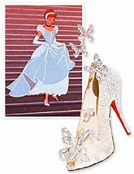

Cinderella’s Shoe Store

123 Enchanted Castle Drive

Marathon, FL 33219

Dear Students,

My name is Cinderella and I have had problems with wearing the wrong shoes. I tried wearing glass slippers and they were awful! They are uncomfortable, fragile, and sometimes fall off when I run. I am an avid runner and glass slippers just won’t do. I decided to open a discount athletic shoe store with my partner Snow White.

Our discount shoe company recently opened in your area. We would like to hold a “Grand Opening Promotion - One Day Blow-Out Sale” to help attract new customers and build sales. The promotion will feature all our most popular athletic footwear. We know how excited our customers will be to get their favorite shoes at a discounted price!

We need your help in determining which Famous Brand Sneaker we should promote for our One Day Sale. Our goal is to increase the number of new customers, as well as increase our sales and profits during the One Day Sale.

We would like your team to calculate the **Total Profit Margin per pair** as well as, the **Total Sales Potential Profit margin** determined by the **number of sneakers in stock**. We also would like your team to develop a step-by-step procedure for ranking our Famous Brand Sneakers to see which one will provide the most profit, as well as bring in the most customers.

Again, we would like you to consider the following criteria when developing your ranking procedure: comfort and durability, along with the profit margin per pair and the total potential profit margin determined by the number of sneakers available in stock. Please rank our Famous Brand Sneakers from 1 to 5 according to the above criteria. Remember, our goal is to increase our sales and profits while building up our customer base.

Please write a letter back to us listing your step-by-step procedure for ranking our Famous Brand Sneakers. Also, include how you decided which one we should feature for our One Day Blow-Out Sale and why. Be detailed in your procedures and reasons. Thank you in advance for your efforts to help our company!

Sincerely,

Cinderella

**Data Set 1** C:\Users\norupc\AppData\Local\Microsoft\Windows\Temporary Internet Files\Content.IE5\LD9SHNQE\MC900019554[1].wmf **Cinderella’s Shoe Store**

|  |  |  |  |  |  |  |  |  |
| --- | --- | --- | --- | --- | --- | --- | --- | --- |
| Famous Brand  Sneakers | **Style** | **Comfort** | **Durability** | **Amount of Stock available** | **Whole Sale**  **Cost per pair** | **Retail Cost per pair** | **Total Profit margin**  **per pair** | **Total Sales**  **Potential**  **Profit margin** |
| NiTe | C:\Users\norupc\AppData\Local\Microsoft\Windows\Temporary Internet Files\Content.IE5\LD9SHNQE\MC900440070[1].wmf | Very Good | Excellent | 62 pairs | $89.42 | $124.99 |  |  |
| Conburst | C:\Users\norupc\AppData\Local\Microsoft\Windows\Temporary Internet Files\Content.IE5\1XQYL4PC\MC900440066[1].wmf | Excellent | Good | 54 pairs | $64.21 | $99.50 |  |  |
| Adidam | C:\Users\norupc\AppData\Local\Microsoft\Windows\Temporary Internet Files\Content.IE5\XEWN29IL\MC900440064[1].wmf | Good | Very good | 92 pairs | $56.42 | $78.25 |  |  |
| Vants | C:\Users\norupc\AppData\Local\Microsoft\Windows\Temporary Internet Files\Content.IE5\X2K8TMKW\MC900440231[1].wmf | Very Good | Excellent | 67 pairs | $68.13 | $108.00 |  |  |
| Rebock | C:\Users\norupc\AppData\Local\Microsoft\Windows\Temporary Internet Files\Content.IE5\1XQYL4PC\MC900440054[1].wmf | Good | Very Good | 88 pairs | $64.49 | $89.50 |  |  |

Answer Key 1 C:\Users\norupc\AppData\Local\Microsoft\Windows\Temporary Internet Files\Content.IE5\LD9SHNQE\MC900019554[1].wmf**Cinderella’s Shoe Store**

|  |  |  |  |  |  |  |  |  |  |
| --- | --- | --- | --- | --- | --- | --- | --- | --- | --- |
| Famous Brand  Sneakers | **Style** | **Comfort** | **Durability** | **Amount of Stock available** | **Amount of Additional Stock delivered** | **Whole Sale**  **Cost per pair** | **Retail Cost per pair** | **Total Profit margin**  **per pair** | **Total Sales**  **Potential**  **Profit margin** |
| NiTe | C:\Users\norupc\AppData\Local\Microsoft\Windows\Temporary Internet Files\Content.IE5\LD9SHNQE\MC900440070[1].wmf | Very Good | Excellent | 62 pairs | 12 pairs | $89.42 | $124.99 | $124.99  -$ 89.42  $35.57 | $35.57  x 74 $2,632.18 |
| Conburst | C:\Users\norupc\AppData\Local\Microsoft\Windows\Temporary Internet Files\Content.IE5\1XQYL4PC\MC900440066[1].wmf | Excellent | Good | 54 pairs | 15 pairs | $64.21 | $99.50 | $99.50  -$ 64.21  $35.29 | $35.29  x 69 $2,435.01 |
| Adidam | C:\Users\norupc\AppData\Local\Microsoft\Windows\Temporary Internet Files\Content.IE5\XEWN29IL\MC900440064[1].wmf | Good | Very good | 92 pairs | 10 pairs | $56.42 | $78.25 | $78.25  -$ 56.42  $21.83 | $21.83  x 102  $2,226.66 |
| Rebock | C:\Users\norupc\AppData\Local\Microsoft\Windows\Temporary Internet Files\Content.IE5\1XQYL4PC\MC900440054[1].wmf | Good | Very Good | 88 pairs | 18 pairs | $64.49 | $89.50 | $89.50  -$ 64.49  $25.01 | $25.01  x 106  $2,651.06 |
| Vlada | C:\Users\norupc\AppData\Local\Microsoft\Windows\Temporary Internet Files\Content.IE5\LD9SHNQE\MC900440042[1].wmf | Fair | Excellent | 77 pairs | 5 pairs | $56.72 | $95.25 | $95.25  -$56.72  $38.53 | $38.53  x 82 $3,159.46 |
| Pumu | C:\Users\norupc\AppData\Local\Microsoft\Windows\Temporary Internet Files\Content.IE5\XEWN29IL\MC900083091[1].wmf | Excellent | Good | 81 pairs | 13 pairs | $59.23 | $79.50 | $79.50  -$59.23  $20.27 | $20.27  x 94 $1,905.38 |

**Data Set 2** C:\Users\norupc\AppData\Local\Microsoft\Windows\Temporary Internet Files\Content.IE5\LD9SHNQE\MC900019554[1].wmf **Cinderella’s Shoe Store**

|  |  |  |  |  |  |  |  |  |  |
| --- | --- | --- | --- | --- | --- | --- | --- | --- | --- |
| Famous Brand  Sneakers | **Style** | **Comfort** | **Durability** | **Amount of Stock available** | **Amount of Additional Stock delivered** | **Whole Sale**  **Cost per pair** | **Retail Cost per pair** | **Total Profit margin**  **per pair** | **Total Sales**  **Potential**  **Profit margin** |
| NiTe | C:\Users\norupc\AppData\Local\Microsoft\Windows\Temporary Internet Files\Content.IE5\LD9SHNQE\MC900440070[1].wmf | Very Good | Excellent | 62 pairs | 12 pairs | $89.42 | $124.99 |  |  |
| Conburst | C:\Users\norupc\AppData\Local\Microsoft\Windows\Temporary Internet Files\Content.IE5\1XQYL4PC\MC900440066[1].wmf | Excellent | Good | 54 pairs | 15 pairs | $64.21 | $99.50 |  |  |
| Adidam | C:\Users\norupc\AppData\Local\Microsoft\Windows\Temporary Internet Files\Content.IE5\XEWN29IL\MC900440064[1].wmf | Good | Very good | 92 pairs | 10 pairs | $56.42 | $78.25 |  |  |
| Rebock | C:\Users\norupc\AppData\Local\Microsoft\Windows\Temporary Internet Files\Content.IE5\1XQYL4PC\MC900440054[1].wmf | Good | Very Good | 88 pairs | 18 pairs | $64.49 | $89.50 |  |  |
| Vlada | C:\Users\norupc\AppData\Local\Microsoft\Windows\Temporary Internet Files\Content.IE5\LD9SHNQE\MC900440042[1].wmf | Fair | Excellent | 77 pairs | 5 pairs | $56.72 | $95.25 |  |  |
| Pumu | C:\Users\norupc\AppData\Local\Microsoft\Windows\Temporary Internet Files\Content.IE5\XEWN29IL\MC900083091[1].wmf | Excellent | Good | 81 pairs | 13 pairs | $59.23 | $79.50 |  |  |

**Answer Key 2** C:\Users\norupc\AppData\Local\Microsoft\Windows\Temporary Internet Files\Content.IE5\LD9SHNQE\MC900019554[1].wmf**Cinderella’s Shoe Store**

|  |  |  |  |  |  |  |  |  |  |
| --- | --- | --- | --- | --- | --- | --- | --- | --- | --- |
| Famous Brand  Sneakers | **Style** | **Comfort** | **Durability** | **Amount of Stock available** | **Amount of Additional Stock delivered** | **Whole Sale**  **Cost per pair** | **Retail Cost per pair** | **Total Profit margin**  **per pair** | **Total Sales**  **Potential**  **Profit margin** |
| NiTe | C:\Users\norupc\AppData\Local\Microsoft\Windows\Temporary Internet Files\Content.IE5\LD9SHNQE\MC900440070[1].wmf | Very Good | Excellent | 62 pairs | 12 pairs | $89.42 | $124.99 | $124.99  -$ 89.42  $35.57 | $35.57  x 74 $2,632.18 |
| Conburst | C:\Users\norupc\AppData\Local\Microsoft\Windows\Temporary Internet Files\Content.IE5\1XQYL4PC\MC900440066[1].wmf | Excellent | Good | 54 pairs | 15 pairs | $64.21 | $99.50 | $99.50  -$ 64.21  $35.29 | $35.29  x 69 $2,435.01 |
| Adidam | C:\Users\norupc\AppData\Local\Microsoft\Windows\Temporary Internet Files\Content.IE5\XEWN29IL\MC900440064[1].wmf | Good | Very good | 92 pairs | 10 pairs | $56.42 | $78.25 | $78.25  -$ 56.42  $21.83 | $21.83  x 102  $2,226.66 |
| Rebock | C:\Users\norupc\AppData\Local\Microsoft\Windows\Temporary Internet Files\Content.IE5\1XQYL4PC\MC900440054[1].wmf | Good | Very Good | 88 pairs | 18 pairs | $64.49 | $89.50 | $89.50  -$ 64.49  $25.01 | $25.01  x 106  $2,651.06 |
| Vlada | C:\Users\norupc\AppData\Local\Microsoft\Windows\Temporary Internet Files\Content.IE5\LD9SHNQE\MC900440042[1].wmf | Fair | Excellent | 77 pairs | 5 pairs | $56.72 | $95.25 | $95.25  -$56.72  $38.53 | $38.53  x 82 $3,159.46 |
| Pumu | C:\Users\norupc\AppData\Local\Microsoft\Windows\Temporary Internet Files\Content.IE5\XEWN29IL\MC900083091[1].wmf | Excellent | Good | 81 pairs | 13 pairs | $59.23 | $79.50 | $79.50  -$59.23  $20.27 | $20.27  x 94 $1,905.38 |

Dear Cinderella,

Congratulations on the opening of your new Discount Store! We are excited to help you decide on the best Famous Brand Sneaker for your “Grand Opening Blow-Out One Day Sale”! After reviewing the different brands and criteria available, we decided to rank them as follows.

|  |  |  |  |  |  |  |
| --- | --- | --- | --- | --- | --- | --- |
| Famous Brand  Sneakers | **Amount of Stock available** | **Whole Sale**  **Cost per pair** | **Retail Cost per pair** | **Total Profit margin**  **per pair** | **Total Sales**  **Potential**  **Profit margin** | **Reason for Choice** |
| 1) |  |  |  |  |  |  |
| 2) |  |  |  |  |  |  |
| 3) |  |  |  |  |  |  |
| 4) |  |  |  |  |  |  |
| 5) |  |  |  |  |  |  |

The process we used in our rankings and reasons are as follows: First_________________________________________________________________________­­­­­­­­­­­­­­next__________________________________________________________________________

then__________________________________________________________________________and___________________________________________________________________________finally,____________________________________________________________________________________.

We were glad to help with your promotion. If there’s anything else we can do, please let us know.

Sincerely,

Cinderella’s Shoe Store 

123 Enchanted Castle Drive

Marathon, FL 33219

Dear Students,

Thank you for all your hard work in ranking our famous brands. I can tell you put a great deal of thought into it. Unfortunately, there has been a change in the selection of our Famous Brand Sneakers. One of the brands sold out this past weekend due to the half-mile marathon on Saturday; therefore, I have removed it from the list. I decided to include two other Famous Brand Sneakers for you to choose from. I was also able to acquire additional stock from one of our other stores.

Our “Grand Opening Promotion - One Day Blow-Out Sale” is scheduled for this upcoming Saturday. We know this does not give you a lot of time to make the new calculations necessary. You will also need to determine if your procedure for choosing the best brand to feature still works. If not, please develop another step-by-step procedure based on the new criteria.

Remember to calculate the **Total Profit Margin per pair** as well as, the **Total Sales Potential Profit margin** determined by the **Total number of sneakers now in stock** and also for the two additional brands. Please develop a second step-by-step procedure for ranking our Famous Brand Sneakers to see which one will provide the greatest profit, as well as bring in the most customers. Please rank our Famous Brand Sneakers again from 1-6 according to the new criteria.

Please write a letter back to us listing your new step-by-step procedures for ranking our Famous Brand Sneakers. Also, include how you decided which one we should feature for our One Day Blow-Out Sale and why. Be detailed in your procedures and reasons. Once again, thank you in advance for your efforts to help our company!

Sincerely,

Cinderella

Dear Cinderella,

After reviewing the changes to the brand selections and the additional stock, we decided to rank the Famous Brand Sneakers as follows.

|  |  |  |  |  |  |  |
| --- | --- | --- | --- | --- | --- | --- |
| Famous Brand  Sneakers | **Amount of Total Stock available** | **Whole Sale**  **Cost per pair** | **Retail Cost per pair** | **Total Profit margin**  **per pair** | **Total Sales**  **Potential**  **Profit margin** | **Reason for Choice** |
| 1) |  |  |  |  |  |  |
| 2) |  |  |  |  |  |  |
| 3) |  |  |  |  |  |  |
| 4) |  |  |  |  |  |  |
| 5) |  |  |  |  |  |  |
| 6) |  |  |  |  |  |  |

The process we used in our rankings and reasons are as follows: First_________________________________________________________________________________next_________________________________________________________________________________

then________________________________________________________________________________

finally,________________________________________________________________________________

Our original procedure changed from our first ranking in this way:

We were glad to help with your promotion and wish you well for a successful “Grand Opening Blow-Out One Day Sale”!

Sincerely,

The Boston Globe

**Sneaker freaks live to buy, sell, trade shoes**

By Sandra A. Miller

The hobby is an obsession, and sometimes a lucrative one, for these young collectors.

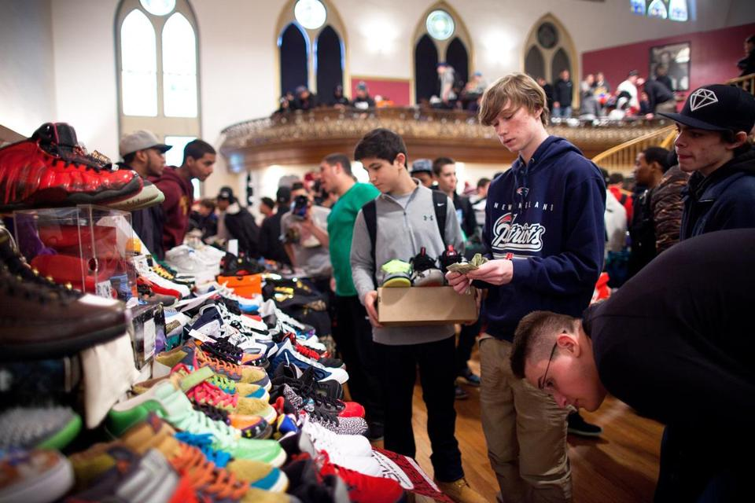

DINA RUDICK/GLOBE STAFF

A sneaker resell event called Boston Got Sole 2, held in January at Boston’s Villa Victoria, drew some thousand collectors.

**By Sandra A. Miller**   MARCH 16, 2014

AT 9 A.M. ON A SATURDAY in February, some 60 teenagers and twentysomethings — all males except for one 15-year-old girl — stand in a line that snakes down Brattle Street in Harvard Square. Huddled in parkas or dark hoodies, they slap their arms and shuffle their feet, attempting to ward off the bitter cold. Most have been waiting since 6 a.m. Some slept in their cars after arriving the night before from Boston and beyond, desperate to acquire one of the approximately 60 numbered plastic bracelets the sneaker boutique[Concepts](http://www.cncpts.com/) will hand out. When the store opens at 10, only those customers with a bracelet will be allowed to purchase the coveted Nike shoe dropping that day: Dunk High Premium SB Diamond, better known (because of their aqua color) as Tiffany SBs. The shoes cost $125 a pair, and Concepts is limiting sales to one pair per customer.

For some sneakerheads, as the collectors are called, buying the shoe is feeding a passion. For others it’s a day’s work, as the resell value on these limited-release sneakers will escalate by the afternoon. But for everyone involved, from the shoe manufacturer to the retailer to the freezing kid in line ready to give up a wad of cash for a new pair of kicks, it’s just part of the sneaker game — a phenomenon of buying, collecting, selling, swapping, and competing for this sought-after street-fashion accessory.

“I love collecting shoes,” says Jonathan Tran, a 21-year-old pharmacy student in Boston who has been a sneakerhead since high school and owns about 40 pairs, which he says are worth $15,000. Tran estimates he’s bought, sold, or traded 200 pairs of sneakers in the past six years and has done almost 50 camp-outs at footwear stores in the Boston area, one lasting 36 hours. “My friend and I went to Concepts a week before a special Air Jordan release, and there were kids from New York already camping,” Tran says. “Then we found out [Champs](http://www.champssports.com/) in Burlington was getting them, so we went there.” This was July 2011. While police evicted kids from the Burlington Mall property, Tran slept in a folding chair across the street and eventually scored a pair of green and white Ray Allen 13s for $160. The next day he sold them for $900. “That was my first come-up, in terms of making money,” Tran says. “It was crazy.”

Like most enterprising sneakerheads, Tran is well aware of the intersection of passion and profit. He estimates he’s made $18,000 to $20,000 by reselling shoes, mostly through online forums or Facebook. Sneakerheads often close deals on eBay or through sneaker consignment stores such as [Flight Club](http://www.flightclub.com/) in New York. A blurry line now distinguishes a true sneakerhead, in it mostly for the love of shoes, from the scorned “hypebeast” — a person who will line up for every new shoe just to turn a profit or impress his peers. “I don’t get hyped for everything,” Tran says. “I usually get shoes that I want to wear.”

“The hype drives the prices up,” says Jason Crane, the 38-year-old store manager of[Expressions](http://www.expressionsstores.com/) at South Shore Plaza in Braintree and longtime sneakerhead. He says resellers like Flight Club are hurting the retail vendors. “If Flight Club is getting $500 for a shoe, and the retail is $130, the next year it comes out, it’s $180, and then $200.”

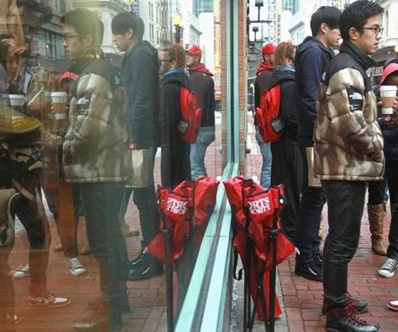

WENDY MAEDA/GLOBE STAFF

Sneakerheads waited outside Expressions in Boston in February to buy the just-released Jordan Infrared 6s.

[[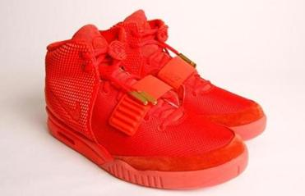](http://www.bostonglobe.com/magazine/2014/03/16/how-got-schooled-counterfeit-sneakers/ztLiZygcgrwOr5cqVZcC4N/story.html?p1=Article_Related_Box_Article)](http://www.bostonglobe.com/magazine/2014/03/16/how-got-schooled-counterfeit-sneakers/ztLiZygcgrwOr5cqVZcC4N/story.html?p1=Article_Related_Box_Article)

Over the years Crane has seen a lot of changes in the footwear industry. “I was pre-Jordan” — mad about sneakers even as a boy — “and now I’m post-Jordan,” he says. He’s referring to the year 1984, when Nike signed an endorsement deal with NBA newcomer Michael Jordan and turned the sneaker game on its head. As the story goes, the NBA and the Chicago Bulls banned the rookie from wearing his black, white, and red Air Jordans during games, insisting he don the team colors of red and white. In response, Nike built an ad campaign around Air Jordans that capitalized on the controversy and, with the help of the burgeoning sub-brand, resuscitated the Oregon company.

“Back then Jordans were a luxury item, and that started people being robbed for them,” says Crane. “Then they became more mainstream, and parents moved away from this idea of $59 for a sneaker that would last kids a whole year. They started spending $100, $150 on a shoe. Parents have been conditioned.” And so have kids. Now Crane sees youngsters of 9, 10, and 11 who have saved all summer to buy their dream shoes. Different cities have distinct sneaker flavors, and in Boston, that would be old-school Adidas. “It’s a fashionable shoe at a good price point,” Crane says. “They’re still not over a hundred dollars, and you can get them in a variety of colors to match with your outfits.” Out in the suburbs, he adds, they’re more into Nike and Jordan.

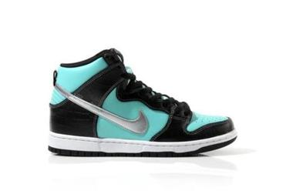

Nike Dunk High Premium SB Diamond

According to Matt Powell, an analyst with retail research firm [SportsOneSource](http://www.sportsonesource.com/index.asp) in Boulder, Colorado, retail sales of athletic shoes in the United States reached $22 billion last year. Greater Portland, Oregon, is home to the three top selling brands—Nike, Jordan (owned by Nike), and Adidas. But Greater Boston is an industry hub as well, with major offices for more brands than any other US city: Converse (owned by Nike), Puma, Reebok (owned by Adidas), Saucony, and New Balance. (Adidas and Puma are German companies.)

While no one knows how much of the retail store market can be attributed to sneakerheads, Josh Luber, founder of Philadelphia-based [Campless.com](http://www.campless.com/), a resell-tracking data company, estimates that in terms of secondary sales on eBay, sneakerheads accounted for approximately $200 million in 2013.

“In dollars and cents, sneakerheads make up a tiny portion of the industry,” Powell says, “but their fervor certainly creates heightened interest in shoes.”

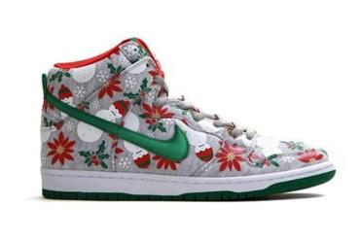

Nike SB Ugly Christmas Sweater

[THE VILLA VICTORIA CENTER FOR THE ARTS](http://www.iba-etc.org/arts.html) in the South End is packed. It’s a Saturday afternoon in January, and skinny 12-year-old boys carry orange Nike boxes stacked higher than their heads. A crowd made up largely of guys in their teens and 20s jostles shoulder to shoulder, most hawking pairs of colorful kicks. Hoping to do a deal, they mill around, holding up a sneaker, calling out the shoes’ style names, and sometimes the size or price.

“New Year’s Eve Question.”

“Ugly Christmas Sweater, size 10.”

“Oregon Duck Foams, $700.”

Booths around the room’s periphery hold pyramids of shoes, one table featuring a pair of Red Dons — a Kanye West and Louis Vuitton collaboration — displayed like a museum piece under plexiglass. Asking price $2,500.

This is [Boston Got Sole 2](https://www.facebook.com/events/470771053033419/), a convention for buying, selling, and trading sneakers, and 14-year-old Jonathan DiModica, a Weymouth High School freshman, is running the show. When DiModica’s family house burned to the ground in 2012, his mother bought him a pair of low-end Jordans to replace his old sneakers that “smelled like barbecue” after the fire. His shoe obsession was born.

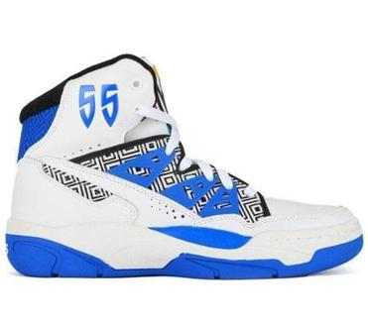

Adidas Mutombo

To earn money for more pairs, DiModica and his best friend launched a business cleaning up old shoes and taking out creases. In the collecting world, a shoe’s value is directly related to its condition, with the most desirable shoes for resell being “deadstock” — sneaker slang for never worn. DiModica also charged $60 to camp out for shoes for other sneakerheads.

When the South Shore Plaza put an end to camp-outs for security reasons, DiModica and his brother, Joseph, now 17, organized Boston Got Sole. The success of that first event, held in September at the Villa Victoria, led the brothers to hold this second convention four months later. Their mom and dad are on hand, working the door and selling pizza. The five-hour event draws some thousand sneakerheads, at $10 or $15 a ticket, roughly double the attendance of the brothers’ first show.

“What I’m doing right now is bringing the sneaker culture of Boston together,” Jonathan shouts over the din of the crowd and hip-hop music spun by [DJ Papadon](http://djpapadon.com/). “I’ve met thousands of people, doing what I do, and I know I’ll meet thousands more. It’s a great vibe, a lot of great people.”

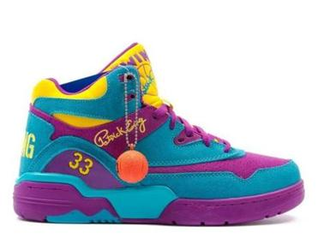

Ewing Guard

The mob is mostly male, with maybe a dozen female sneakerheads in the entire room. One of them, 18-year-old Ali Enaire, wanders around trying to sell her men’s size 6 Jordan Raptors 7s. (Most female sneakerheads wear smaller men’s sizes.) She isn’t feeling hopeful about it — the resell culture does its greatest volume in the male-friendly sizes of 10 and 11.

Eventually, Enaire does manage to sell her Raptors — to another female. She also buys a pair of South Beach Lebrons from a younger boy.

“The sneaker game is different for women. It’s bittersweet, in a way,” says Asia Mai, an assistant manager at the Allston sneaker consignment store [At the Buzzer](http://www.atbboston.com/). “Guys come in thinking I’m a female that has no knowledge or opinions about sneakers. They’ll point to a shoe instead of asking for it by name because they don’t want to embarrass me. I end up surprising them when I know it.”

Mai says it’s devastating when shoes don’t come in small sizes. “Luckily, some brands make shoes exclusively in women’s sizes,” she says, “so that females can have a pair of dope kicks that guys break their necks at.”

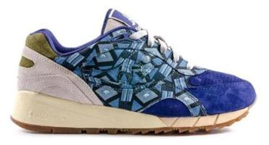

Saucony Elite Shadow 6000

As the organizer of the [New England Sneaker Social](http://www.eventbrite.com/e/new-england-sneakersocial-sneaker-social-tickets-10087683533?aff=eorg), to be held April 6 at Gillette Stadium, the largest venue ever for a sneaker event in New England, 20-year-old Tyler Blake says he’s eager to include female sneakerheads. “We have actively worked to make the show have a wide appeal and not be so male-dominated. From brand presence with women’s sizing to special collaborations, women will be able to partake in the event to the fullest extent.” Blake is expecting around 1,500 sneaker lovers.

For now, though, it’s largely a young man’s game. “I think sneakers have become more of a status symbol than any other consumer product for urban males in a certain age group,” says 21-year-old Ben Adams-Keane, whose sneaker drawing won Nike’s Future Sole design contest in 2008 when he was a sophomore at Arlington High School. As a result of his win, Adams-Keane, now a liberal arts student at Bard College in New York state, spent the next three years doing freelance footwear design for Nike. “Sneakers are a cultural icon wrapped up in exclusivity,” he says. “There’s an urge to have something rare.”

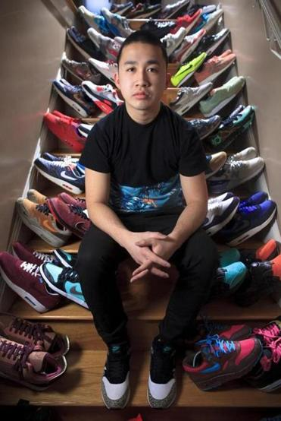

DINA RUDICK/GLOBE STAFF

Collecting since high school, 21-year-old Jonathan Tran has made at least $18,000 reselling sneakers.

As for the so-called hypebeast ruining the game, Adams-Keane says the game itself is infused with hype, and shoe companies feed the culture of desire through limited releases. “I don’t think there has ever been a sneaker game that was genuine in the way that people want to pretend,” he says. “What is real is that these shoes are amazing examples of art and design. We fill them with stories and convene around them.”

Michael Jordan “is the father of the sneakerhead culture,” according to DJ Clark Kent, an Emerson College graduate, sneaker fan, and hip-hop producer based in Brooklyn. “He’s the reason there’s super hype about sneakers, because of the stories that were told about him,” says Kent (real name Rodolfo Franklin). “It was him. It wasn’t the shoe. You believed you could play like Michael Jordan. He was so far ahead of everybody that the shoes became magical.”

The 47-year-old Kent hosts an online sneaker talk show called [Quickstrike](http://www.complex.com/tv/shows/quickstrike) and wears only virgin shoes (some “seeded” by sneaker companies — supplied to him for free). His “once and done” approach is “about looking fresh,” he says. (The used shoes go to individual kids or to charities.) Although Kent has designed shoes for Nike, he says he’s not beholden to any brand. “I wear what I want to wear. I don’t wear anything because of hype.” His personal favorites are Nike’s classic white Air Force 1s. “They’re so perfect, so clean, so simple.”

Kent says the online hype preceding every new shoe release has killed the sense of discovery he felt as a kid when he fell in love with sneakers. “There’s no more walking into the store and getting excited about a shoe and thinking to yourself, *I don’t think anybody knows about that.* Everybody knows about everything now.”

But that hasn’t stopped kids from lining up to buy. At 10:20 a.m. outside Concepts, the first three customers walk out with their Tiffany-blue and black boxes. They pause for a moment to peek under the lids and admire their hard-won purchases. “I’m keeping mine and wearing them,” one says. His friends agree. But they won’t break them out until spring, when the snow and salt are gone. They pack up their boxes and head to IHOP around the corner for breakfast. By the afternoon, Tiffany SBs are going for $375 on eBay.

*Sandra A. Miller is a writer in Arlington. Send comments to*[*magazine@globe.com*](mailto:magazine@globe.com)*.*