Cinderella’s Shoes
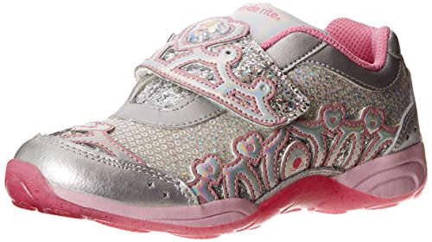
Cinderella has joined the track team and glass slippers are just not working out. In this model eliciting activity, students will determine which shoe is the best to purchase for Cinderella’s track team. Students will be required to convert measurements initially and then rank the shoes from best to worst based on the data provided.
Subject(s): Mathematics, English Language Arts
Grade Level: 5
Suggested Technology: Document Camera, Interactive Whiteboard, LCD Projector, Microsoft Office
Instructional Time: 2-4 Hour(s)
Keywords: metric system, conversion, measurement, problem-solving
LESSON CONTENT
- Lesson Plan Template: Model Eliciting Activity (MEA)
- Formative Assessment
Ask students to answer to following questions:
- How many meters are in a kilometer?
- If I walked at a speed of 5 kilometers per hour, how far could I walk in 3 hours?
- If I walked 20 kilometers in 2 hours, how fast was I walking?
- Feedback to Students
Students will be receiving feedback throughout the lesson as they think aloud and explain or justify their thinking throughout the lesson as they work cooperatively. The teacher should be asking questions that probe students to think about the process they are implementing as they discuss their process.
- Summative Assessment
The teacher will determine if the students have reached the learning targets for this resource by the calculations they make with the first and second data set If students explain their process and calculations verbally and/or in writing, they have met the target for this lesson. The teacher will measure the impact of this resource on student learning by his or her observations of the way students present the information to the class and based on the assessment.

- Learning Objectives
  - Students will use the metric system to convert measurements.
  - Students will work in a team.
  - Students will write a letter in response to the client.
  - Students will make decisions about the process to determine which shoe is the best based on the data provided for each.
- Prior Knowledge
Students need to understand the metric system and how to convert within this system. Students also need to have basic problem-solving skills.
Instructional Suggestions
Task 1:
- Readiness Questions
  - How many of you like to run?
  - Where do you run?
  - What types of shoes do you wear when you run? Why do you wear those shoes?
  - Give students Disney Star Track Runner Letter 1 and Data Set 1.
  - Have students take turns reading the client letter out loud or individually.
- Comprehension/readiness questions
  - Do you understand what the client is looking for?
  - What is the client asking you to do?
  - Do you think your process makes sense? Why?
  - What will you need to do with the data before you can begin to rank it?
    - After reading the letter and understanding their objective, allow students to work in teams of 3-4.
    - Once students have started their thinking process, walk around and listen to student conversations assist by asking guiding questions.
• Guiding/reflective Questions
- Why is it important for runners to have the best shoe?
- How do you think you will begin to decide which shoe is better?
- Are any of the criteria on the data table more important than others?
- Can the data be ranked from most important to least important?
- Why did you decide that was an important/not an important factor in choosing a shoe?
- How many meters are in a kilometer?
- How can you figure out how many hours of running the shoe will last for?
- Are there any other ways to find an answer to that?
    - Allow students to explain and justify their thinking.
    - After they have discussed their process, have students explain how they completed the task.
    - At this point, they can share out with other classmates. They can use document camera to show their work to classmates.
• Reflection question
- Do you think you would be able to apply these processes if other information was added about the shoe? Would your process have to change?
Task 2:
  - Give students Disney Star Track Runner Letter 2 and Data Set 2.
  - Have students take turns reading the Disney-Star Track Runners Letter 2 letter out loud or individually.
  - After reading the letter and understanding their objective, allow students to work in their teams again.
  - Once students have started their thinking process, walk around and listen to student conversations asking guiding questions.
• Guiding/reflective Questions
- Why is it important for runners to have the best shoe?
- How do you think you will begin to decide which shoe is better?
- Are any of the criteria on the data table more important than others?
- Can the data be ranked from most important to least important?
- Why did you decide that was an important/not an important factor in choosing a shoe?
- How many meters are in a kilometer?
- How can you figure out how many hours of running the shoe will last for?
- Are there any other ways to find an answer to that?

  - Allow students to explain and justify their thinking.
  - After they have discussed their process, have students explain how they completed the task in their letter to the client. (Students Letter Template 2 can be used if needed).
  - At this point, they can share out with other classmates. They can use a document camera to show their work to classmates.
ACCOMMODATIONS & RECOMMENDATIONS
- Suggested Technology: Document Camera, Projector
- Accommodations:
  - The teacher can have students complete the problem as a whole class or in pairs instead of groups.
  - The teacher can also extend the time allowed to complete the lesson.
  - To differentiate instruction, the teacher can model how they would begin the rating of the shoes.
- Extensions:
Have students create their own category for the shoes that may result in a change in the original data.
- Learn about 3-D printed shoes. How would the availability of 3-D printed shoes change shoe selection for the track team? Would they use the same criteria for as they did in the first two data tables for determining the best 3-D printed shoes?
http://www.popsci.com/technology/article/2012-07/3d-printed-shoe-could-help-save-sprinters-precious-seconds
http://www.popsci.com/technology/article/2013-06/foot-prints
After reading the story, use the text to have students understand how the market economy works today (in terms of shoes)
- Explain how buyers and sellers use trade and money when buying shoes.
- Think about how people got shoes in the past. Do some research and discuss how Native Americans got shoes? Did they have stores a long time ago? If they didn’t, how did they get shoes? Did they have money? If not, what do you think they used to trade for shoes?
- http://www.nativetech.org/clothing/moccasin/moctext.html
- What about people living in Colonial America? Read through the articles. Compare and contrast the shoe store experience in Cinderella’s’s shoes with colonial times. http://www.history.org/Almanack/life/trades/tradesho.cfm
- http://www.history.org/history/teaching/shoemkr.cfm
Related Standards
Name | Description
LAFS.4.W.1.2: | Write informative/explanatory texts to examine a topic and convey ideas and information clearly.
LAFS.5.W.1.2: | Write informative/explanatory texts to examine a topic and convey ideas and information clearly.  - Introduce a topic clearly, provide a general observation and focus, and group related information logically; include formatting (e.g., headings), illustrations, and multimedia when useful to aiding comprehension.  - Develop the topic with facts, definitions, concrete details, quotations, or other information and examples related to the topic.  - Link ideas within and across categories of information using words, phrases, and clauses (e.g., in contrast, especially).  - Use precise language and domain-specific vocabulary to inform about or explain the topic.  - Provide a concluding statement or section related to the information or explanation presented.
MAFS.4.MD.1.1: | Know relative sizes of measurement units within one system of units including km, m, cm; kg, g; lb, oz.; l, ml; hr, min, sec. Within a single system of measurement, express measurements in a larger unit in terms of a smaller unit. Record measurement equivalents in a two-column table. For example, know that 1 ft is 12 times as long as 1 in. Express the length of a 4 ft snake as 48 in. Generate a conversion table for feet and inches listing the number pairs (1, 12), (2, 24), (3, 36), ...
MAFS.5.MD.1.1: | Convert among different-sized standard measurement units (i.e., km, m, cm; kg, g; lb, oz.; l, ml; hr, min, sec) within a given measurement system (e.g., convert 5 cm to 0.05 m), and use these conversions in solving multi-step, real world problems.
SC.5.P.8.1 | Compare and contrast the basic properties of solids, liquids, and gases, such as mass, volume, color, texture, and temperature.
SS.5.E.1.2 | Describe a market economy, and give examples of how the colonial and early American economy exhibited these characteristics.

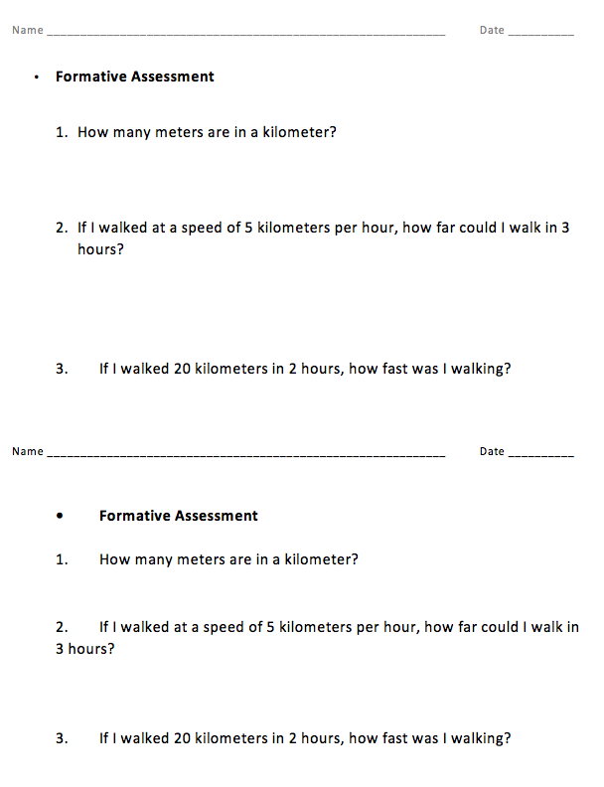

Client Letter 1 Passage 1

Dear Engineering Team,
My name is Cinderella and I run on a track team called “Disney-Star Track Runners.” I have had problems with running in glass slippers, if they don’t break, they fall off. It is a serious problem when I want to run fast. My teammates and I want to make a change. We are trying to see which shoe is the best one for running. We are looking at how long the shoes lasts, how runners rate the comfort of the shoe, the mass of the shoes, the texture of the tread on the shoes, how well air flows through the shoes to cool the feet, and the cost of the shoes. Coach Mickey told us that shoes that have a mass of over 1 kilogram may slow us down.
The texture of the bottom of the shoe is especially important to my runners on days when the track is wet. Poor traction can cause runners to slip and fall. Good airflow helps sweat to evaporate, keeping runner’s feet cooler on hot days.
I hope you can write a letter back to me telling me the process on how you decided how to rank the shoe from best to worst. Also, we measure running distance in kilometers, but the data we received from the shoe manufacturers is in meters. If you can convert meters to kilometers, it will help some of the runners understand the information better.
In your letter, make sure you describe the process on how you decided how to rank the shoe from best to worst. I look forward to hearing back from you!
Sincerely,
Cinderella
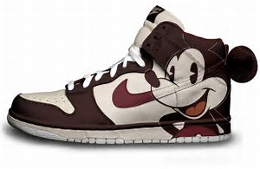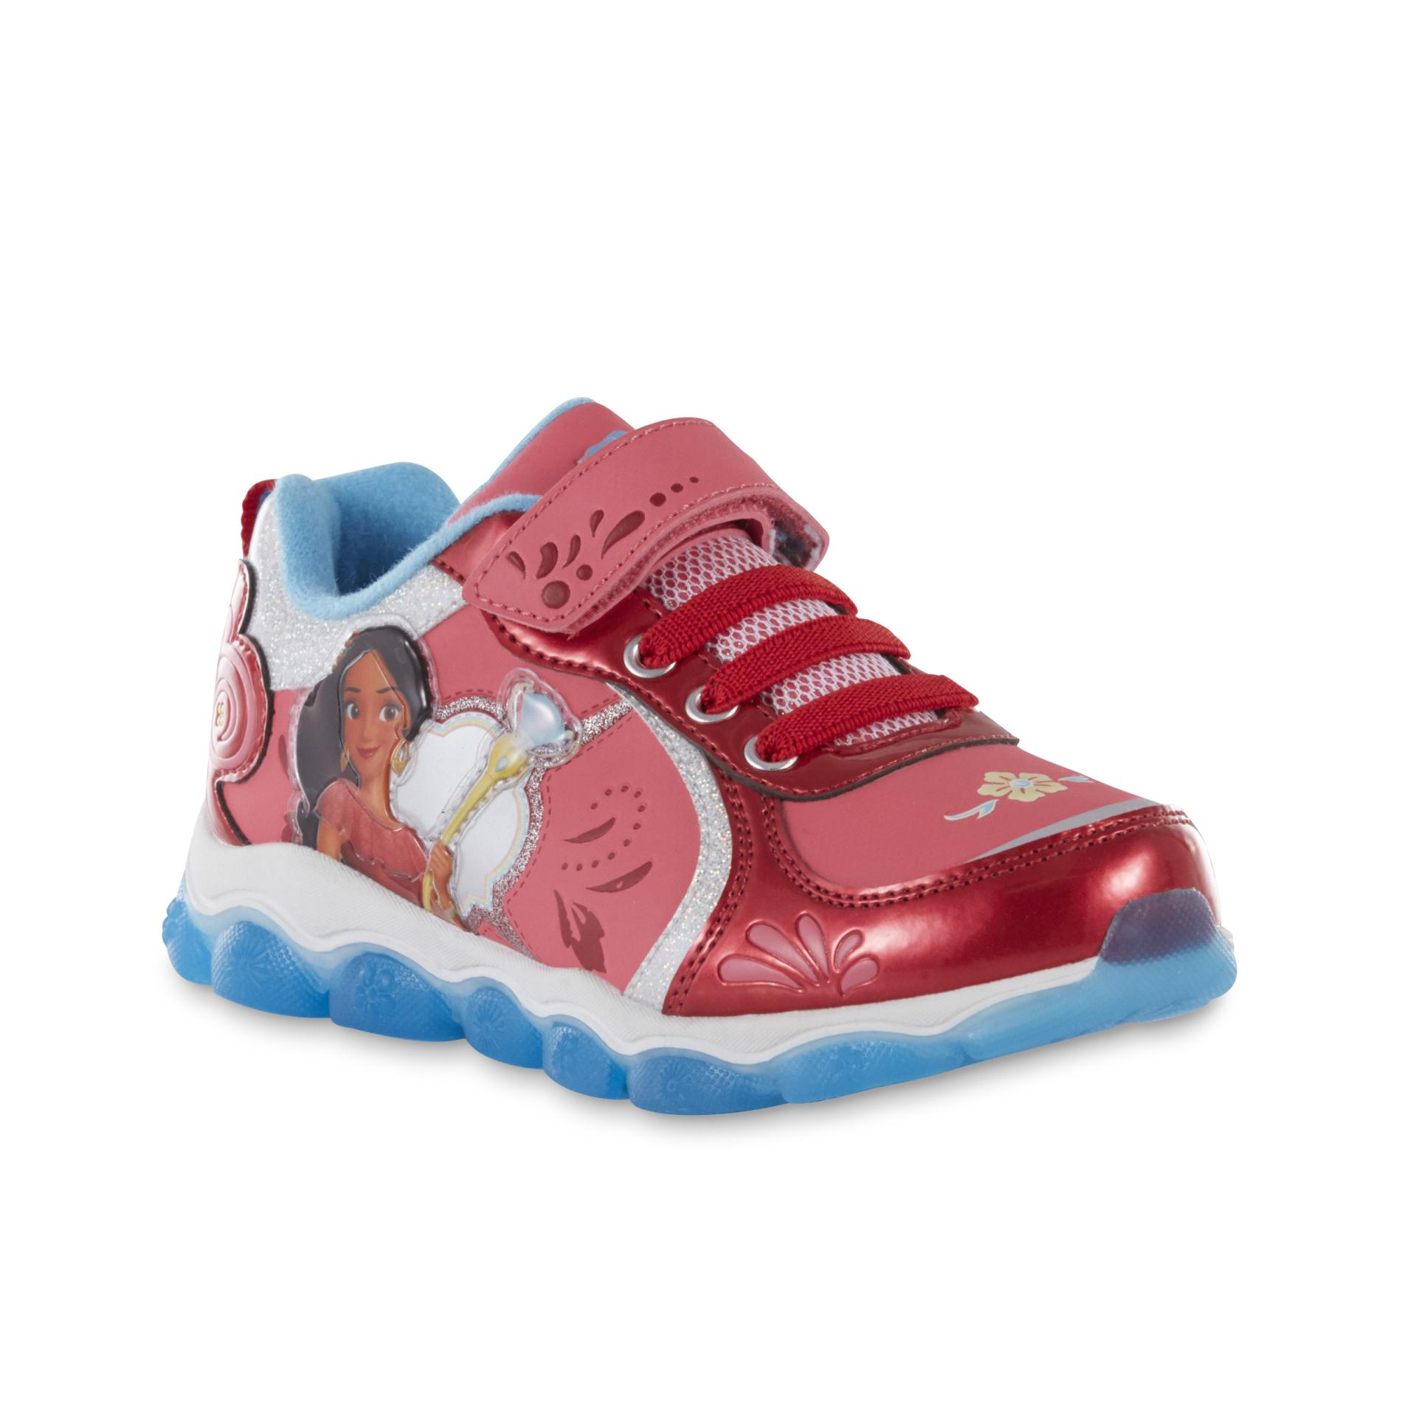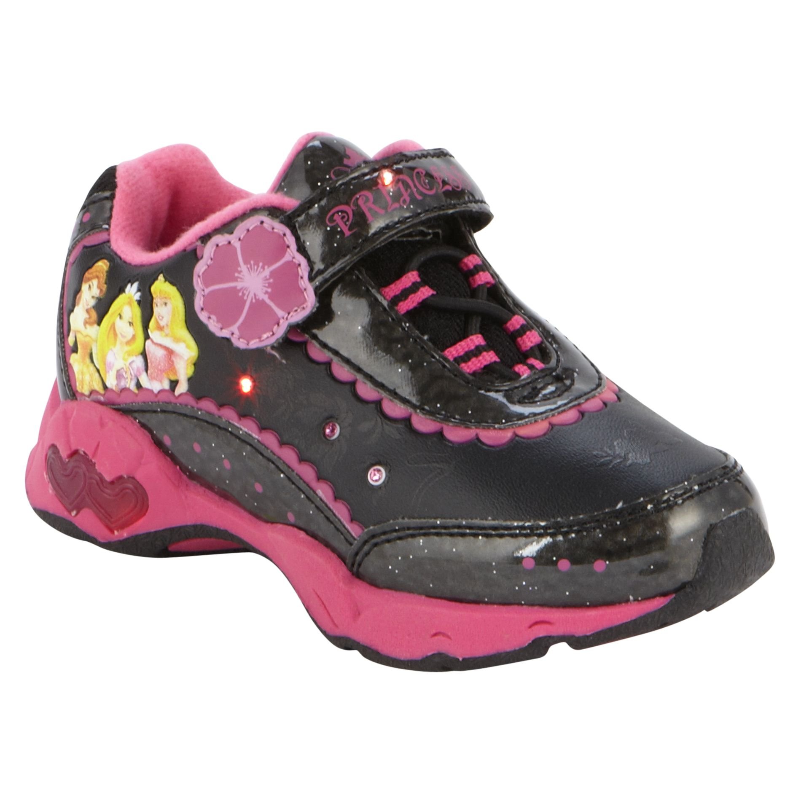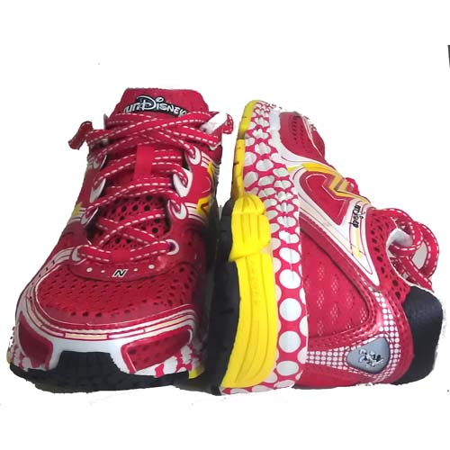

Disney-Star Track Runners Data Set 1

Shoe Brand | Average Distance ran before shoe showed wear (meters) | Average Distance ran before shoe showed wear (kilometers) | Comfort Rating | Mass | Texture  (How good is the traction) | Airflow through upper of shoe | Price per pair
Goofy Shoe Plus | 11,000 m |  | 1 | 1135g | 5 | 9 | $82
Minnies's Choice | 8,000 m |  | 4 | 963g | 2 | 6 | $123
Shoes of Doom | 9,000 m |  | 4 | 981g | 4 | 6 | $126
Peter Pan Flyers | 13,000 m |  | 3 | 1096g | 4 | 7 | $97

Rating scale: 1-10 (1 being the best, 10 being the worst)

Notes:

There are 1,000 meters in 1 kilometer.
There are 1,000 grams in 1 kilogram.

Dear Cinderella,

Our Team, _________________________, has determined the ranking for the shoes is as follows:
1) ____________________________, 2) ____________________________, 3) ____________________________, 4) ____________________________.

Our first choice was _______________________because:

This is the procedure we followed for making our decision: ________________________________________________________________________________________________________________________________________________________________________________________________________________________________________________________________________________________________________________________________________________________________________________________________________________________________________________________________________________________________________________________________

Sincerely,

Hello,
Thanks for helping me pick the right shoe for my team. The information in your letter was helpful. I was able to include two more shoe brands, which may help in deciding if we are keeping the same ranking in the shoes or if we have to change it.
My runners often practice running early in the morning before the sun is out. Reflective sneakers help motorists to better see the runners and keep runners safer. I was also able to get information on the shoe colors and whether they are reflective, but I don’t know if you will need this information.
Will your original process still work with this new data?. Let me know whether or not you make changes to your system of choosing when you write back. If you made changes to your system, or chose a different shoe based on the new data, please make sure to tell me what changes you had to make. Thanks again!
Sincerely,
Cinderella
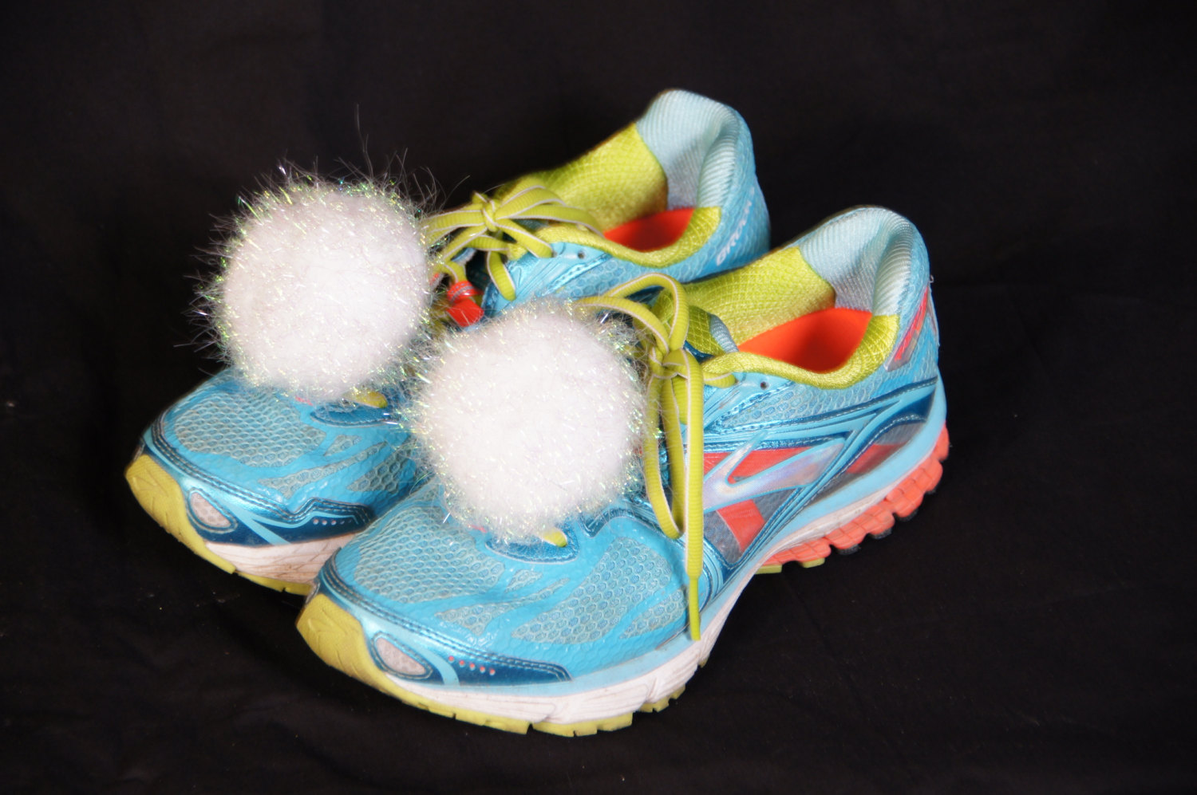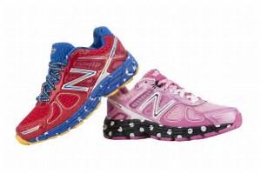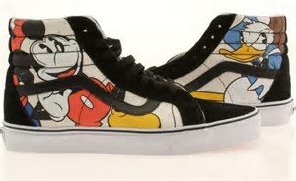
Disney-Star Track Runners Data Set 2
Shoe Brand | Average Distance Ran before shoe showed wear (meters) | Average Distance Ran before shoe showed wear (kilometers) | Comfort Rating | Mass | Color  (How reflective is it?) | Texture  (How good is the traction) | Airflow through upper of shoe | Price per pair
Goofy Shoe Plus | 11,000 m |  | 1 | 1135g | 3 | 5 | 9 | $82
Minnies's Choice | 8,000 m |  | 4 | 963g | 8 | 2 | 6 | $123
Shoes of Doom | 9,000 m |  | 4 | 981g | 6 | 4 | 6 | $126
Peter Pan Flyers | 13,000 m |  | 3 | 1096g | 9 | 4 | 7 | $97
Tiggers Bouncers | 10,000 m |  | 2 | 1009g | 3 | 3 | 5 | $72
Lion Kings | 9,000 m |  | 4 | 858g | 5 | 1 | 2 | $176
Snow White Runners | 12,000 m |  | 3 | 947g | 6 | 7 | 3 | $119

Notes:

There are 1,000 meters in 1 kilometer.
There are 1,000 grams in 1 kilogram.

Dear Cinderella,

Our Team, _________________________ (did/did not) have to change our original procedure.
The ranking for the shoes is as follows:

1) ____________________________
2) ____________________________
3) ____________________________
4) ____________________________

We made the decision for the best shoe by ___________________________________________________________________________________________________________________________________________________________________________________________________________________________________________________________________________
Sincerely,

Summative Assessment Name

Shoe Brand | Average Distance ran before shoe showed wear (meters) | Average Distance ran before shoe showed wear (kilometers)
Track Shoe Plus | 11,000 m
Runner's Choice | 8,000 m
Mickey’s Kicks |  | 12km

- A runner ran 11 kilometers before his shoes were worn out and needed to be replaced. How many meters was he able to run in those shoes for before they wore out? Explain how you solved this problem.

- Cinderella’s Disney Star Track team ran the 5 kilometer race at four track meets last month.
If they ran 5 kilometers four times, how many meters did they run? Explain your answer.

