Voices for Justice

Social Studies Benchmarks:

For this decision-making lesson, students will research four activists and determine which one should be promoted on With Liberty and Justice for All’s advertising materials.
Problem
Which activist should be promoted on With Liberty and Justice for All’s advertising materials?

Alternatives
Judy Bonds, W. W. Law, Craig Kielburger, Elizabeth Cady Stanton

Criteria
Identified a problem that threatened the health and/or safety of others, made an impact on his or her community, made an impact beyond his or her community, results of his or her work is still evident today

Decision
How were these activists ranked? How was that decision reached?

Read the letter from With Liberty and Justice for All. Discuss the problem (which activist should be promoted on the organization’s advertising materials), the alternatives (Judy Bonds, W. W. Law, Craig Kielburger, Elizabeth Cady Stanton) and the criteria (identified a problem that threatened the health and/or safety of others, made an impact on his or her community, made an impact beyond his or her community, results of his or her work is still evident today).

- Discuss how activism is a way that citizens work together to influence government and help solve community and state problems.
- Use the link below to begin a discussion on how any citizen can make a difference is his or her community:
  - How to Change the World – Kid President https://www.youtube.com/watch?v=4z7gDsSKUmU
  - Connect the concepts in the video to what students see in today’s world and with the work of the four candidates for Voice for Justice.
- Show pictures (on the lesson plan below) of the activists who are being considered by With Liberty and Justice for All.
- Provide students with the decision-making matrix or note-taking tool, and review the alternatives and criteria.
- Use the links below to research each activist. Stop frequently to discuss the criteria and take notes.
  - Judy Bonds
http://www.nytimes.com/2011/01/16/us/16bonds.html
https://www.youtube.com/watch?v=WifwMfgwHk4
b. W. W. Law
http://www.savannahga.gov/index.aspx?NID=1908 (biography, primary sources)
https://www.youtube.com/watch?v=yxNxp2rO4hA
c. Craig Kielburger
http://www.peaceherostories.org/young-peace-heroes
https://www.youtube.com/watch?v=D3DD5mLmwcg
d. Elizabeth Cady Stanton
https://www.womenshistory.org/education-resources/biographies/elizabeth-cady-stanton
https://www.youtube.com/watch?v=nCEaHGgUV-Q
- Working in groups, students discuss the criteria for each activist. Which one meets the criteria for being named Voice for Justice? Why? Rank the choices from highest to lowest.
- Encourage students to discuss their processes for making their choices. What did they do first? After that?
- Groups write a letter to explaining how they made their choices.
Extension/ideas:
- Have each group create a presentation explaining how they made their choices.
- Research other activists who brought change to their communities.
- Learn more about the everyday people can make a difference at ReadWorks:
  - Peer Pressure Power https://www.readworks.org/article/Peer-Pressure-Power/f5939357-7009-4786-92a7-5c772683f4c6#!articleTab:content/
  - How Can You Help? https://www.readworks.org/article/How-Can-You-Help/d289530b-5c02-4f72-a685-97e3c2de9d93#!articleTab:content/
  - Harriet Tubman and the Underground Railroad https://www.readworks.org/article/Famous-African-Americans---Harriet-Tubman-and-the-Underground-Railroad/bf86d318-2804-4d41-ac76-3ef4aa7dc51b#!articleTab:content/

Differentiation:
- Reduce alternatives and/or criteria.
- Increase alternatives and/or criteria.
- Provide note-taking tools with some of the information from Reading Wonders, videos, and/or web articles already filled in.

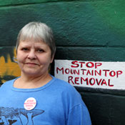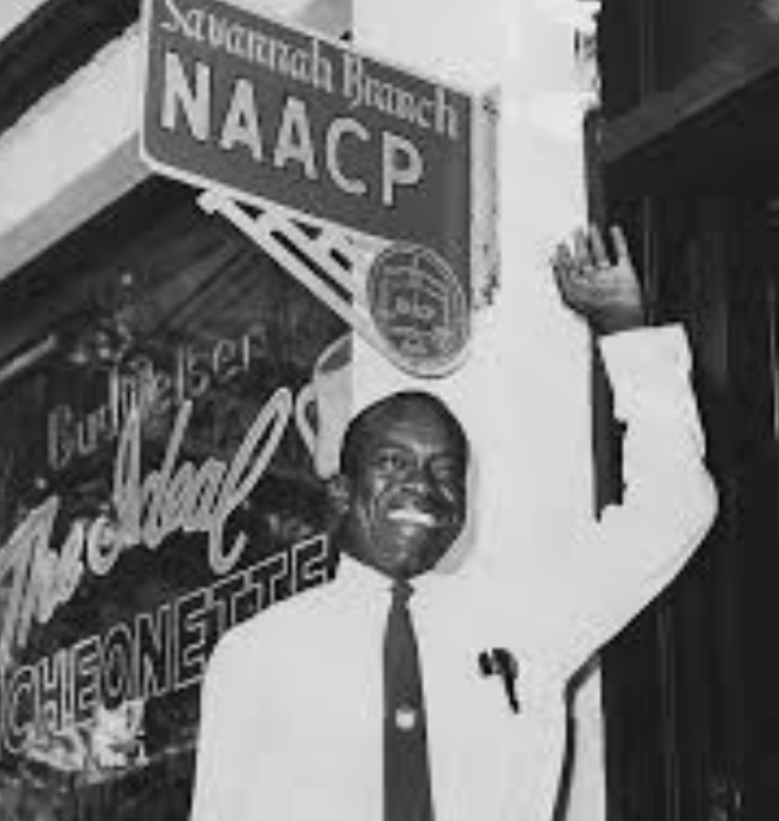
Judy Bonds W. W. Law
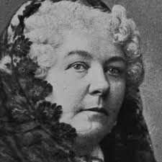
Craig Keilburger Elizabeth Cady Stanton

