Bear, Bees, and Wildflowers

In this decision-making lesson, students will help pick a flower that Bear can plant to help them gather more nectar to make more honey.

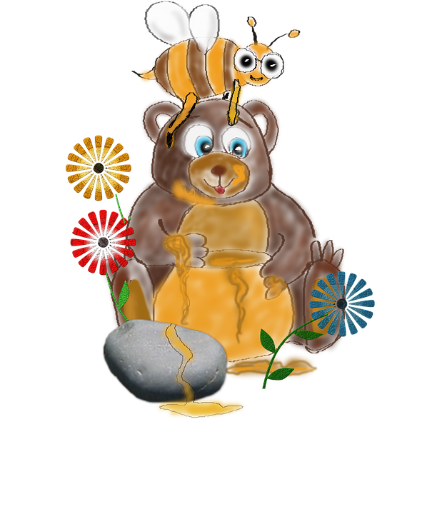

Instructional Suggestions
  - The teacher will start by reading Please, Please the Bees.
  - The teacher will read the Letter from Bear Aloud (pg 3)
  - The teacher will ask questions for them to determine what problem they need to solve.
  - The students will get a copy of the data set for their use. Talk with the students about different types of flowers and what flowers need to grow on the data sheet (pg. 4)
  - You should review how to read the table with the students, helping them decipher the codes:
    - Winter, Spring, Summer, Fall
    - Size (S-small, M-medium, T-tall)
    - $ means how much it costs. More $’s = more money.
  - Teacher will walk around and facilitate by asking questions (see feedback to students) and have the student explain why they chose that flower and the procedure they came up with.
  - As a group the students will write how they came up with the procedures and rank the flowers from best to work. (See proposal pg 5)
  - Extension: Use the 10-frames (pg 6) and the flowers on page 7 to create a garden.
  - You can use and modify the rubric on page 8
Guiding/reflective Questions
  - How do Bear and the bees trade?
  - What do the bees produce?
  - What does Bear do to help the bees?
  - How do the bees satisfy Bear’s wants?
  - How does Bear satisfy the bees’ needs?
  - Name types of flowers.
  - You need water to live. So do flowers. How do you take care of flowers? What resources do they need? (sun, water)
  - How are these flowers the same? (stem, petals)
  - How are these flowers different? (different color petals, different type of petal)

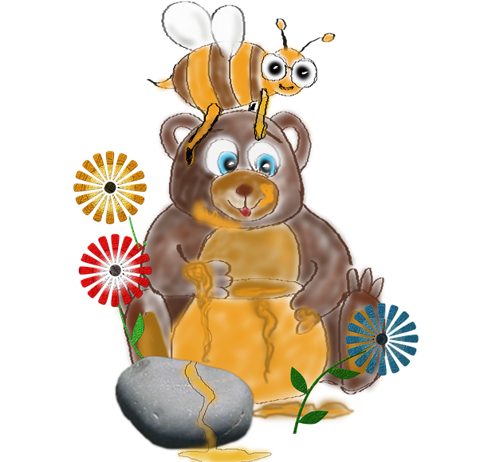
Dear Students,
We need your help! The bees asked me to clean up my garden and plant some flowers so they could make honey. I want to plant a new native Florida Wildflower. The bees and I are trying to decide which Florida Wildflower we should choose to plant. We have created a table with six different choices. Which flower should we choose? Why did you choose that flower?

Happy Flower Finding!
The Bees and Bear
P.S. Here are some things you need to read the table:
Winter, Spring, Summer, Fall
Size (S-small, M-medium, T-tall)
$ means how much it costs. More $’s = more money.

Data Set
Flowers | Color | Bloom Season | Size | Cost
Milkweed  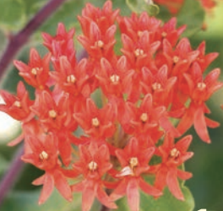 |  |  | M | $$
Thistle  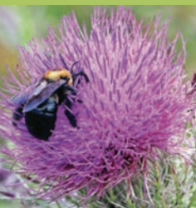 |  |  | T | $
Black-eyed Susan  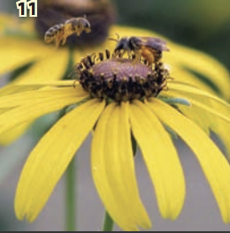 |  |  | M | $$$
Beggarticks  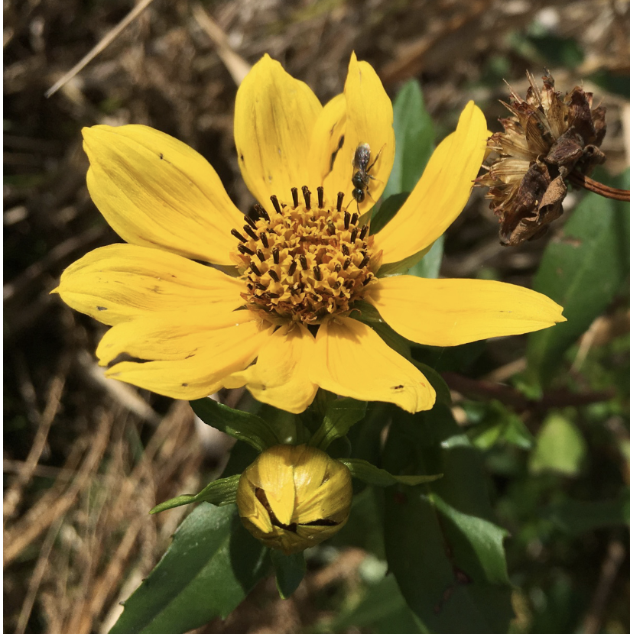 |  |  | M | $
Purple Coneflower  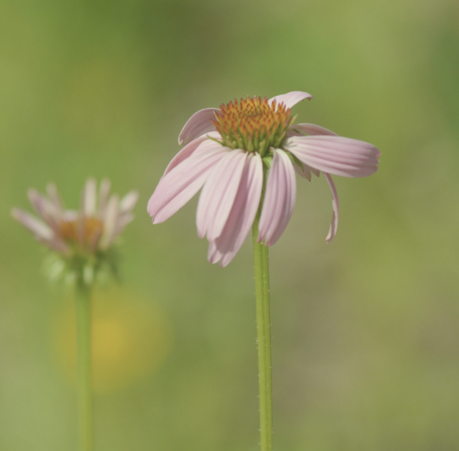 |  |  | M | $$
Blue-eyed Grass  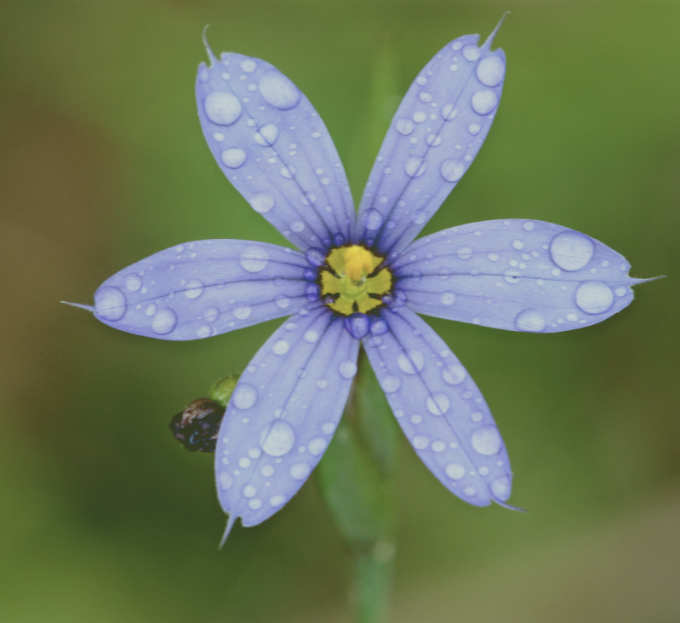 |  |  | S | $

- Proposal
Bear, Bees, and Wildflowers
Names
_____________________,________________________,_____________________

Our group has chosen the ______________________ as the best Florida Wildflower.
We have ranked them in the following order with the best first and the worst last.
1.______________________________________
2.______________________________________
3.______________________________________
4.______________________________________
5.______________________________________

The procedure our group came up with to decide on our Festival Flower

_____________________________________________________________________________________

_____________________________________________________________________________________

___________________________________________________________________

Choose some flowers to plant in your garden.

Possible Rubric
 | Exceeds | Meeting | Progressing
Communication | Communicate verbally which flower was chosen and the procedure used. | Limited communication of which flower was chosen and the procedure. | Unable to communicate which flower was chosen and the procedure
Problem Solving | Uses a variety of methods to solve the problem. | Use a variety of methods for problem solving with limited support. | Use problem solving with variety of support and unable to identify the problems.
Operations | Demonstrates the ability to add numbers and identify less or more with ease. | Demonstrates the ability to add numbers and identify less or more with support. | Unable to add and identify less or more.

