Cinderella Needs help!
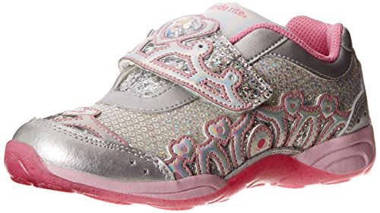

In this open-ended question, students, in teams will make decisions about how to rank shoes based on various shoe characteristics. (eg., color, comfort, shoelaces, lights and customer ratings).
Subject(s): Mathematics, English Language Arts
Grade Level(s): K
Instructional Time: 3 Hour(s)

LESSON CONTENT
- Lesson Plan Template: Model Eliciting Activity (MEA)
- Formative Assessment
These questions should be asked after the first letter has been read. They can also be asked when the students are in cooperative groups as a way keeping them on task.
  - Who are you helping? (Cinderella)
  - What is her problem?(Her feet are growing so he needs bigger shoes.)
  - What does the Cinderella want from you?(To pick the best shoes based on the data.)
- Feedback to Students
The teacher will ask these guiding questions to the students while they work in their small groups.
  - How will you go about choosing a shoe? What will you do first? (answers will vary)
  - How are you going to tell Cinderella how you ranked the shoes? (Students will their explain method)
  - How are you going to complete the letter template? (answers will vary)
- Summative Assessment
The teacher will use the rubric after the students finish the first and second letters.

- Learning Objectives
The student will be able to:
  - Use a combination of drawing, dictating, and writing to compose informative/explanatory texts in which they name what they are writing about and supply some information about the topic.
  - Know number names and the count sequence.
  - Count to tell the number of objects.
  - Compare numbers
- Prior Knowledge
  - Students need to understand how to interpret information from a data table.
  - Students need to be able to count to 20
- Instructional Suggestions
The teacher will then read the first letter (Reading Passage 1) to the class, ensuring the students understand all of the vocabulary.
The teacher will ask the readiness/comprehension questions followed by an introduction to Data Set 1.
    - Who are you helping? (Cinderella)
    - What is her problem? (She needs help choosing a new pair of shoes)
    - What does the client want from you? ( To choose a pair of shoes)
- The teacher will go over the Data Set 1 with the students making sure they understand the key and what each category means.
- Students will then be put into groups and encouraged to brainstorm their ideas.
- Each student will be given a role (reporter, recorder, captain, supplier and spokesperson) optional
- Teams then create a process to solve the client's problem. This will be captured on paper by the recorder.
- The teacher will go from group to group reminding students of the reflection questions and highlighting the information pertinent to the problem.
- Teacher will help the student to organize their writing. Teacher will provide a letter template as well. The teacher may want to have students complete the first part of the letter where they list their choices in writing but then either complete the procedure part verbally or teacher can model writing the answer for them to copy.
- Students will receive the second letter – Reading Passage 2 and Data Set 2, along with their work from the first client letter.
- The teacher will then read the second letter (Reading Passage 2) to the class, ensuring the students understand all of the vocabulary.
- Comprehension/readiness questions
  - Who are you helping? (Cinderella)
  - What is her problem? (She needs help choosing a new pair of shoes)
  - What does the client want from you? ( To choose a pair of shoes)
  - How will you go about choosing a shoe? What will you do first? (answers will vary)
  - How are you going to tell Cinderella how you ranked the shoes? (Students will their explain method)
  - How are you going to complete the letter template? (answers will vary)
- The teacher will go over the Data Set 2 with the students making sure they understand the key and what each category means.
- Students will then be put back into their groups and encouraged to brainstorm their ideas.
- The teacher will go from group to group reminding students of the reflection questions and highlighting the information pertinent to the problem.
- Teams will then determine if their original process can be used to solve the second challenge or if changes need to be made.
- The teacher will then let the groups share their process/procedure with the class.
- Reflection questions 2
  - Did your original process work for the second scenario? Why or why not?
  - Do you think had if there had been more shoes to choose from the process you used would still work?
  - Did adding up the check-marks help you make you decision? How did this help you?
ACCOMMODATIONS & RECOMMENDATIONS
- Accommodations: Work with student one on one.
Have student draw their response.

Related Standards:

SS.K.E.1.3 Recognize that people work to earn money to buy things they need or want. Students investigate texts that explain the connection between producers (workers) and consumers. This standard should be taught with SS.K.E.1.4 so students understand the differences of being a consumer of wants and needs (essential wants.
SS.K.E.1.4 Identify the difference between basic needs and wants.
Students understand that they have many wants. Some of these are needs (Economists define as health wants). Students define their wants and determine which of their wants are needs.
SS.K.C.2.1 Demonstrate the characteristics of being a good citizen.
SC.K.P.8.1 Sort objects by observable properties, such as size, shape, color, temperature (hot or cold), weight (heavy or light) and texture.
MAFS.K.CC.2.5: Count to answer “how many?” questions about as many as 20 things arranged in a line, a rectangular array, or a circle, or as many as 10 things in a scattered configuration; given a number from 1–20, count out that many objects
Math.Practice. MP1 Make sense of problems and persevere in solving them.
Math Practice.MP2 Reason abstractly and quantitatively.

LAFS.K.L.1.1: Demonstrate command of the conventions of standard English grammar and usage when writing or speaking.
LAFS.K.RI.1.1 With prompting and support, ask and answer questions about key details in a text.

LAFS.K.SL.1.1 Participate in collaborative conversations with diverse partners about kindergarten topics and texts with peers and adults in small and larger groups.
- Follow agreed-upon rules for discussions (e.g., listening to others and taking turns speaking about the topics and texts under discussion).
- Continue a conversation through multiple exchanges.

LAFS.K.W.1.2 Use a combination of drawing, dictating, and writing to compose informative/explanatory texts in which they name what they are writing about and supply some information about the topic.

Reading Passage 1
Dear Students,
My name is Cinderella and I am having a hard time choosing a new pair of running shoes. Glass slippers are not working for me, one of them falls off when I run. This is where your help is needed. I need you to look at the data table and rank the shoes from best to worst. I really want to get the best shoes I can. Please write me back soon to let me know the ranks of the shoes and how you chose them.
Thank you,
Cinderella

DATA SET 1
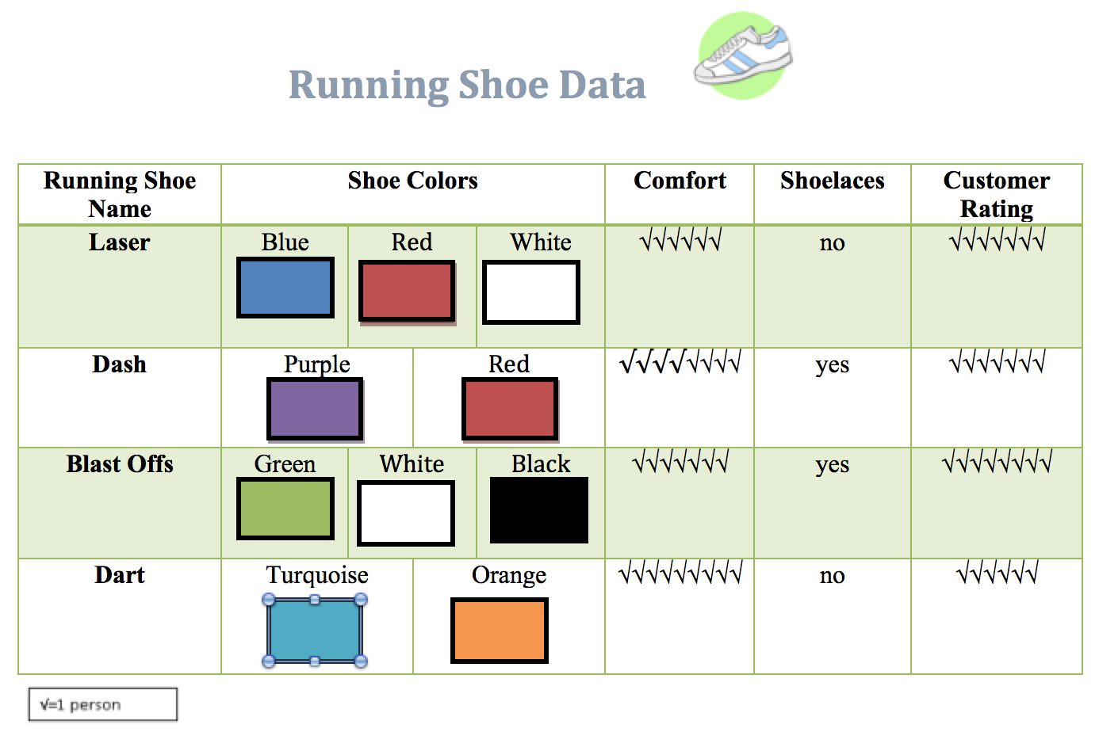

Template Letter 1

Dear Cinderella,

Our team, ______________________________________________________, has determined that you should pick ________________________________________. The order from best shoe to worst is:
- _______________________________________________________________
- _______________________________________________________________
- _______________________________________________________________
- _______________________________________________________________
Our plan for ranking is______________________________________________________________________________________________________________________________________________________________________________________________________________________________________________________________________________________________________________________
Sincerely,

Dear Students,
Thank you for looking at the data table and rank the shoes from best to worst. I just found some other pairs of running shoes that I want you to look at. Will the system you came up with for the first set of data work for this set of data? Please rank this set of data from best to worst and tell me why you ranked them that way. I look forward to finding out which shoes I should get!
Thank you,
Cinderella

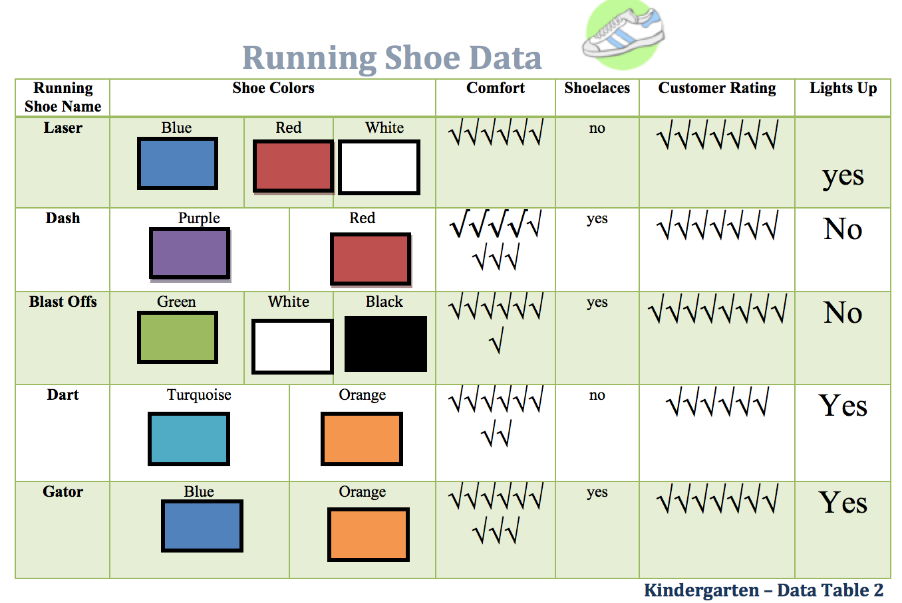

Template Letter 2

Dear Cinderella,
Based on the new data table our team, _______________________________ has now determined that you should pick ________________________________.
The order from best shoes to worst is:
- ____________________________________________________________
- ____________________________________________________________
- ____________________________________________________________
- ____________________________________________________________
- ____________________________________________________________
Our plan for ranking is ________________________________________________
___________________________________________________________________________________________________________________________________________________________________________________________________________________________________________________________________________________________________________________________________________________________________________.
Our plan has (changed from/stayed the same as) our previous plan because:
_______________________________________________________________________________________________________________________________________________________________________________________________________________________________________________________________________________________________________________________.
Sincerely,
RUBRIC
 | Beginning | Progressing | Meeting | Exceeding
Problem Solving | Identifies key information in problems, but needs teacher support to problem solve. | Attempts to use appropriate problem solving strategies including draw a picture, look for a pattern, use objects, or act it out in order to solve problems. | Consistently uses an appropriate problem solving strategy. | Always uses a variety of problem solving strategies to solve the problem.
Communication | Responds to teacher prompts about problem solving strategies. | Begins to explain problem solving strategy and solution with limited language. | Justifies thinking with pictures, numbers, and words. | Consistently explains both verbally and in writing step by step the logic behind the solution.
Computation | No evidence of counting. | Evidence of counting but lacks understanding of how to count on from a number other than 1. | Demonstrates the ability to understand counting on. | Demonstrates the ability to understand apply skip counting strategy and can count on appropriately.
Economics | Understands the difference between wants and needs and can provide examples | Understands the difference between wants and needs and can provide some examples | Understands the difference between wants and needs. | Has difficulty demonstrating understanding of difference.
Civics | Understands characteristics of a good citizen and can provide all examples from the story | Understands characteristics of a good citizen and can provide some examples from the story | Understands characteristics of a good citizen and can provide at least one example from the story | Has difficulty providing examples of good citizenship from the story.

