PACED Decision Making Model
P – Purpose: Find a new job for your favorite superhero.
A – Alternatives: Choose some different alternatives.
C – Criteria: What criteria are important? (consider skills, salaries, and other things you think are important)
E – Evaluate the alternatives: What are the costs and benefits of the different alternatives, based on the criteria you chose?
D –Decision: What decision do you make based on the evidence?
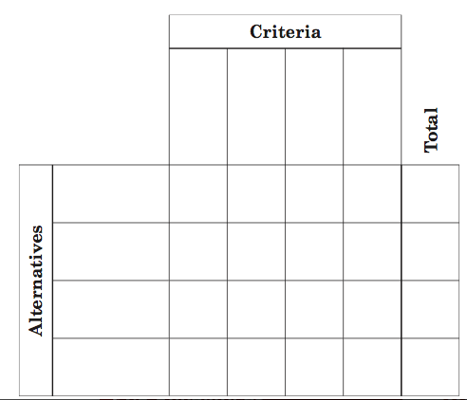

I chose ___________________________________________________________________________because: ___________________________________________________________________________________________________________________________________________________________________________________________________________________________________________________________________________________________________

