PACED Decision Making Model
P – Purpose: What do I want to be when I grow up?
A – Alternatives: Choose some different alternatives.
C – Criteria: What criteria are important to you?
E – Evaluate the alternatives: What are the costs and benefits of the different alternatives, based on the criteria you chose?
D –Decision: What decision do you make based on the evidence?
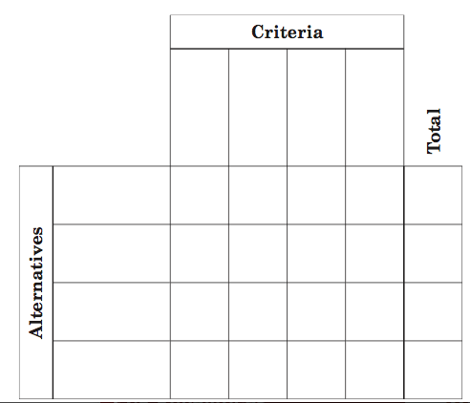

I chose ___________________________________________________________________________because: ___________________________________________________________________________________________________________________________________________________________________________________________________________________________________________________________________________________________________

