PACED Decision Making Model
P – Purpose: Find the best shoe for me.
A – Alternatives: Different shoes that I research
C – Criteria: What do I want in the shoe? (price, comfort, style, etc.)
E – Evaluate the alternatives: What are the costs and benefits of the different alternatives, based on the criteria I chose?
D –Decision: What decision do I make based on the evidence?
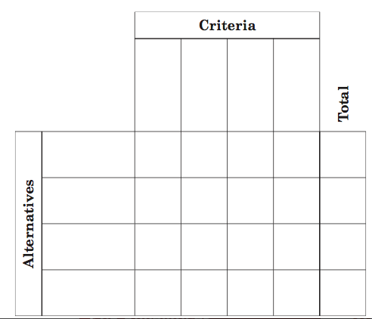

I chose ___________________________________________________________________________because: ___________________________________________________________________________________________________________________________________________________________________________________________________________________________________________________________________________________________________

