PACED Decision Making Model
P – Purpose: Did Scrooge McDuck make the best decisions? Discuss what he did
A – Alternatives: Discuss alternative decisions he could have made
C – Criteria: Scrooge McDuck only thought about saving money. What other criteria are important?
E – Evaluate the alternatives: What are the costs and benefits of the different alternatives, based on the criteria I chose?
D –Decision: What decision do I make based on the evidence?
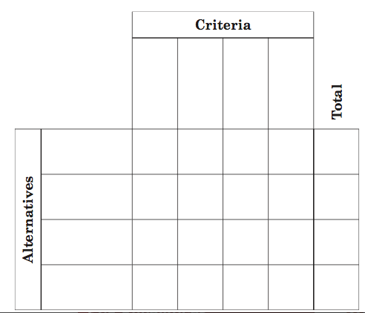

I chose ___________________________________________________________________________because: ___________________________________________________________________________________________________________________________________________________________________________________________________________________________________________________________________________________________________

