Recycling & Conservation: Why Recycle?

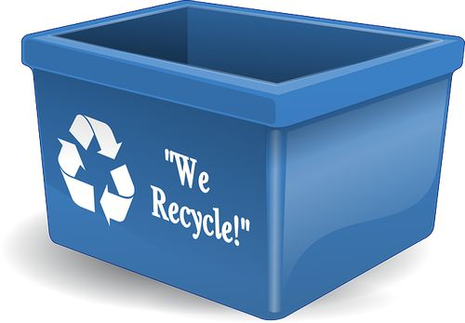

Recycling is a process where something is reused rather than thrown away. Common items that are recycled include aluminum and steel cans, glass, and newspapers. Recycling can be time-consuming and dirty work. For example, recyclable objects have to be sorted from trash. Then the objects have to be cleaned. Afterwards, the objects are turned into materials that can be used by people and companies. Why should people bother to recycle even though it takes a lot of work?
Recycling helps protect the earth. Recycling means less garbage in landfills. These are places where garbage is taken and buried. Recycling also helps conserve the earth’s resources. For example, factories use less energy by recycling steel cans than by making new ones. Recycling paper saves trees from being cut down. Trees are used to make paper.
Every time you are about to drop a plastic bottle in the garbage, stop and think. Is it worth harming the earth? Your actions now can help preserve the environment for generations to come. All you have to do is throw that bottle into a recycling bin.
Get in the habit. Be proud of recycling. Encourage others to recycle. You can make a difference!
© 2012 ReadWorks®, Inc. All rights reserved.

