What Can I Buy?

SS.K.E.1.3 Recognize that people work to earn money to buy things they need or want.

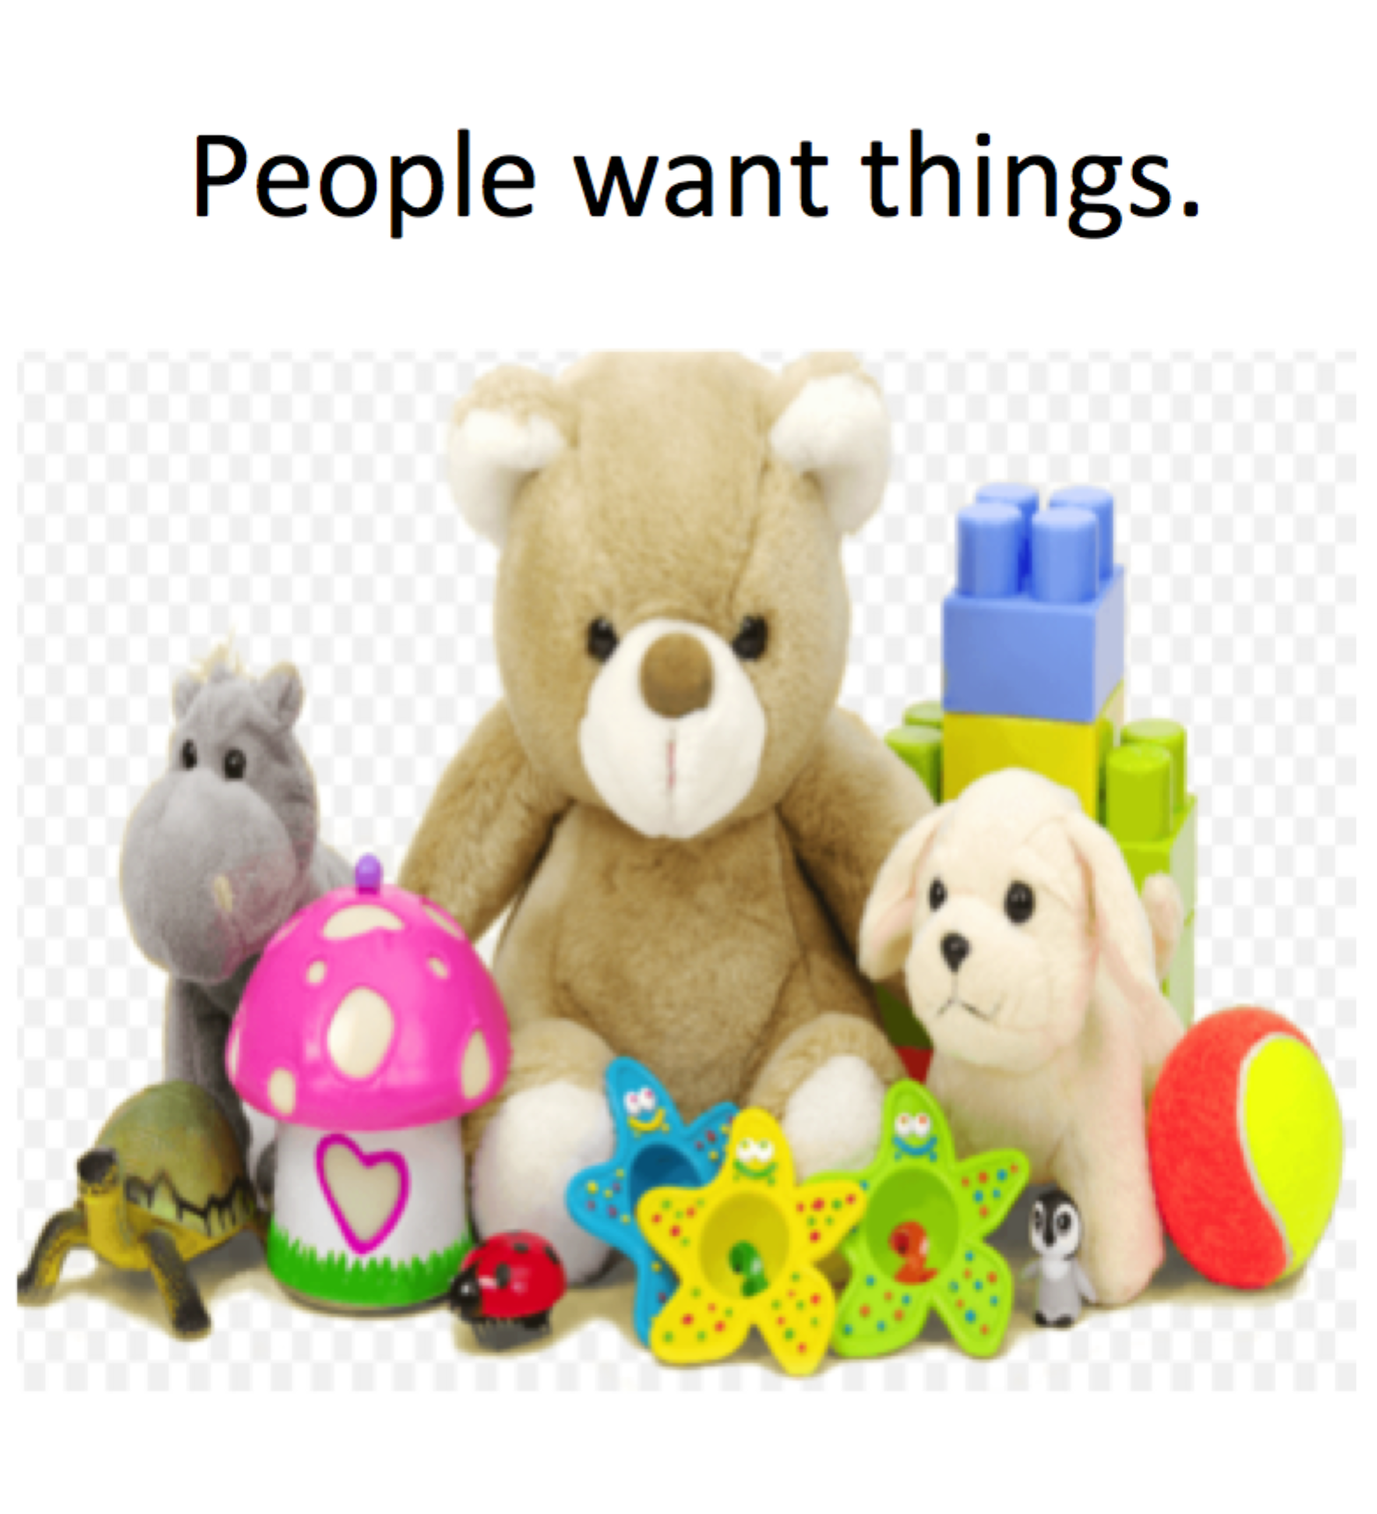

<http://inspiremedianu.com/tag/online-toys/>

<http://kidsforsuccess.com/easy-ways-kids-and-teens-can-make-money>

<http://achildsworldnc.com/teaching-kids-finances/>

<http://www.coupons.com/thegoodstuff/how-to-get-kids-excited-to-save-money/>

